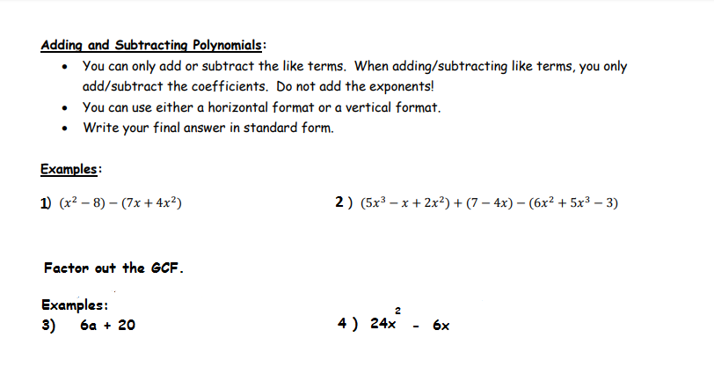
Example 5) Factor x²- 10x - 24
1. Write down two pairs of parentheses.
2. Determine the factors of C.
3. Find the combination of factors that will add/subtract to equal B.
4. Place the values into the parentheses
5. Check your answer using FOIL or box Method.

Slide and Divide Method for Factoring Polynomials

The "slide and divide" method is a way to factor second degree poynomials of the form ax² + bx + c, and is designed for the "hard" case, when the a value of the second degree polynomial is not 1.

This method will be illustrated by using an example. Suppose we want to factor 3x² + x - 10.

1) "Slide" the a value (3) to the end by multiplying it by c (-10). We get: x² + x - 30.

2) We have created the "easy" version, where a = 1. Factor using reverse FOIL (or your favorite method). We get:

(x - 5)(x + 6)

3) Now divide the number parts of these binomials by the value a (3):

(x + 6/3)(x - 5/3)

4) Reduce.

(x + 2)(x - 5/3)

5) If we still have a fraction in either of the binomials, move the denominator from the bottom of the fraction to the coefficient of the variable:

(x + 2)(3x - 5)

6) Check by multiplying back to see if it matches our original polynomial:

(x + 2)(3x - 5) = 3x² + x - 10

We have our original polynomial, so we have found the correct factors.

Example 6)
Factor the trinomials.

Factor the binomials.