11-22 and 11-25
Petway.weebly.com
Math 1
Watch the video for mappings https://www.youtube.com/watch?v=fXESDrVD9ns
Complete the back page of the notes you were given Wednesday (#10-15)
file://h0412sfs03/Home$/Staff/kpetway/Downloads/Guided%20Notes-%20Functions%20and%20Relations.pdf
Take notes on how to write function notation
https://www.youtube.com/watch?v=PCUxU98sNho
Deltamath.com homework – Mappings ( 10 problems)
determine if a graph is a function (10 problems)

Identify Key Features of Graphs

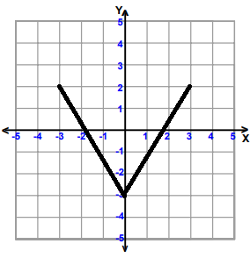
Domain:
Range:
x intercepts:
y- intercepts:
Increasing Behavior:
Decreasing Behavior:
Constant Behavior:
Maxima (maximum):
Minima(minimum):
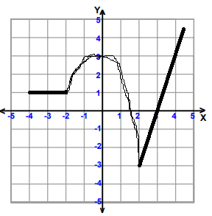
Domain:
Range:
x intercepts:
y- intercepts:
Increasing Behavior:
Decreasing Behavior:
Constant Behavior:
Maxima (maximum):
Minima (minimum):

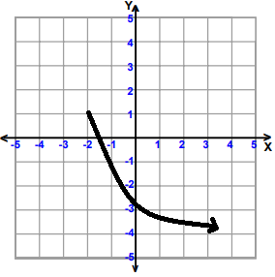
Domain:
Range:
x intercepts:
y- intercepts:
Increasing Behavior:
Decreasing Behavior:
Constant Behavior:
Maxima (maximum):
Minima(minimum):

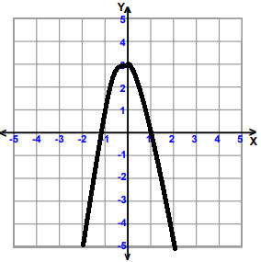
Domain:
Range:
x intercepts:
y- intercepts:
Increasing Behavior:
Decreasing Behavior:
Constant Behavior:
Maxima (maximum):
Minima(minimum):

