Common Core Math II Name Date
Absolute Value Function

The parent Absolute Value function is:
$$y=\left|x\right|$$

As with all other functions we have learned, Absolute value functions can be transformed.

Key Features of Absolute Value Functions

Characteristic Points for $y=\left|x\right|$

Domain:

Range:

Intercept:

Fill in the table below with a description of what happens to the parent function when the following transformations are performed.
Parent Function | $$y=\left|x\right|$$

Description | Transformation
 | $$y=\left|x+h\right|$$
 | $$y=\left|x-h\right|$$
 | $$y=\left|x\right|+k$$
 | $$y=\left|x\right|-k$$
 | $$y=-\left|x\right|$$
 | $$y=a\left|x\right|$$

Let’s look at the following example.
The graph on the right represents a transformation of the graph of
$y=\left|x-3\right|+3$

The description is as follows:

Domain:

Range:

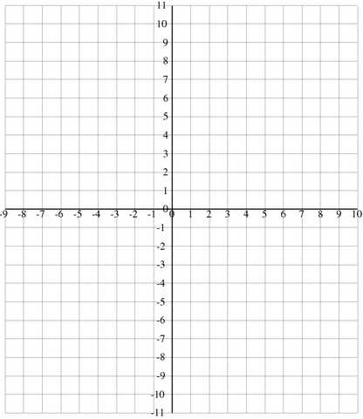
TRY NOW
Graph the following function on the graph at right. Describe each transformation, give the domain and range, and identify any asymptotes.

$y=2\left|x+2\right|-5$

Description:

Domain:

Range:

