Solve the equations. Be sure to check for extraneous solutions.
1. $\sqrt{x+3}-1=7$

2. x - 3 = $\sqrt{2x-7}$

3. 2 = $\sqrt{\frac{x}{2}}$

4. 3$\sqrt{x+6}$ – 10 = 14

5. x = 5 + ( 3x – 11)$\frac{1/2}{}$

6. Describe the translation from the parent function, y = $\sqrt{x}$, of the graph to -3$\sqrt{x+4}$ – 2

7. Describe the translation from the parent function, y = $\frac{1}{x}$ of the graph to y = - $\frac{1}{x}$

8. Describe the translation from the parent function y = $\sqrt[3]{x }$ of the graph to y = - ½ $\sqrt[3]{x -2}$ + 4

9. Find the inverse for the following relation. {(-3, 4), (2, -3) , (-4, 5), -1 . -3)}

10. Find the inverse equation for the following.
a) y = -3x – 12 b) y = -1/3x – 6

11. Graph the function y = -3$\sqrt{x-1}$ + 2
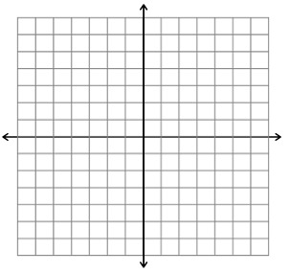

12. Graph the function y = 3$\sqrt[3]{x}$ + 2

13. Graph the function y = -2$\left|x+2\right|$ - 1
14. Sketch the asymptotes and graph the function y $= -\frac{4}{x+2}$ – 3

15. Graph the function y = $\sqrt{-x}$

