Name: Date:

Geometry Practice/Review Concepts
For 1-10, identify the following using the picture to the right.
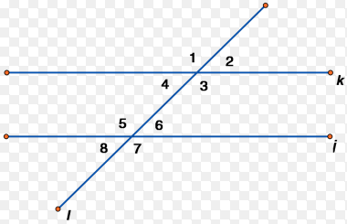
- Alternate interior angles
- Alternate exterior angles
- Vertical angles
- Corresponding angles
- Supplementary angles
- Adjacent angles
- Parallel Lines

- State the difference between an acute angle, an obtuse angle, and a right angle.

- What is the difference between complimentary angles and supplementary angles?

- Identify the differences between an acute, an obtuse, and a right triangle.

Use what you know about angles to find the missing angles below.
1. 2.

3. 4.

5. 6.

h

