**CC2 Practice Mid-Term Name:**

**Multiple Choice: Select the correct answer.**

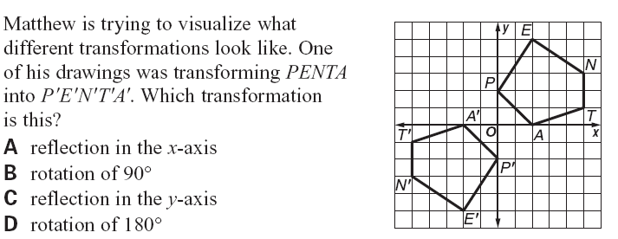1)

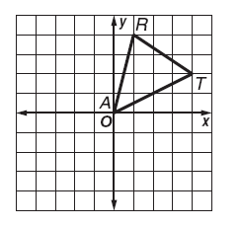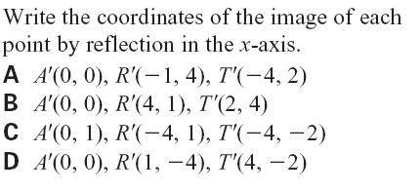

2)



**3) If RAT is dilated by a scale factor of 2,**

**what are the coordinates of R’?**

1. (1, 4)

B. (2, 8)  
C. (8, 2)

D. (2, 1)

**4) A rotation is a transformation that does what?**

1. Flips or folds
2. Spins or turns
3. Both a and b
4. None of these

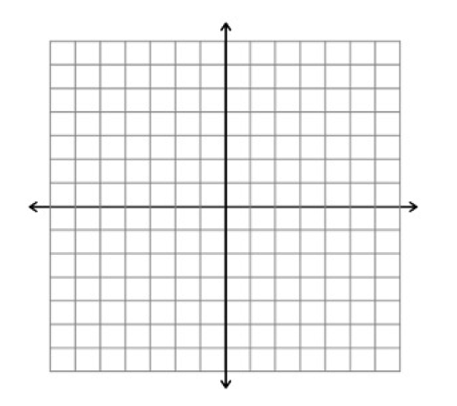**5) Given A (1, 2), B (1, 4), and C (3, 4), find the image of A under a counterclockwise rotation of 90 degrees about the origin.**

1. A’(-2, 1)
2. A’(-1, -2)
3. A’(-2, -1)
4. A’(2, -1)

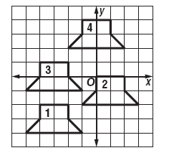**6) Using the figure provided, write a rule to translate figure #3 to figure #4.**

1. (x,y) - > (x+3, y+3)
2. (x,y) - > (x-3, y+3)
3. (x,y) - > (x+2, y-1)
4. (x,y) - > (3x, 1y)

**7) Memorize transformation rules:**

Dilation of scale factor k: 

Translation of (a, b): 

Reflection across y-axis: 

Reflection across x-axis: 

Reflection across y= x: 

Reflection across y= -x: 

Reflection across origin:  Rotation 180o: 

Rotation 90o CCW (and 270o CW): 

Rotation 270o CCW (and 90o CW: 

**For questions 8-10, refer to the graph of the function G(x) to the right.**

**8) For G(x), which of the following is an accurate description of the transformation**

**y=G(x-3)+4?**

a) G(x) translated up 3 units and left 4 units.

b) G(x) translated right 3 units and down 4 units.

c) G(x) translated right 3 units and up 4 units.

d) G(x) translated left 3 units and up 4 units.

**9)** **For G(x), which of the following is an accurate description of the transformation** **y= -G(x) + 6?**

a) G(x) reflected of the x-axis and translated down 6 units.

b) G(x) reflected of the x-axis and translated up 6 units.

c) G(x) reflected of the y-axis and translated down 6 units.

d) G(x) reflected of the y-axis and translated up 6 units.

**10)** **For G(x), which of the following is an accurate description of the transformation**

**y= -G(x - 4) - 6?**

a) G(x) reflected of the x-axis, translated right 4 units and down 6 units.

b) G(x) reflected of the x-axis, translated left 4 units and up 6 units.

c) G(x) reflected of the y-axis, translated right 4 units and down 6 units.

d) G(x) reflected of the y-axis, translated left 4 units and up 6 units.

**11) What are the factors of the quadratic equation $y= x^{2}-10x+24?$**

A) (x + 2)(x + 12) B) (x – 4)(x – 6)

C) (x – 2)(x – 12) D) (x + 4)(x + 6)

**12) What are the factors of the quadratic equation $y= x^{2}+ 6x-16$?**

A) (x + 4)(x + 4) B) (x – 2)(x + 8)

C) (x + 2)(x – 8) D) (x – 4)(x + 4)

**13) What are the solutions for the quadratic equation $y=2x^{2}+2x-12$?**

A) {2,-3} B) {-2,3} C) {2,-6} D) {-2,-6}

**14) What are the solutions to the quadratic equation $y= -3x^{2}-2x+1?$**

A) {6,-5} B) {1,-.3333} C) {-1,.3333} D) {2,.6667}

**15) What is the discriminant for the quadratic function $y=-2x^{2}- x-1?$**

A) 4 B) -7 C) -32 D) 64

**Use the following equations for questions 16-18 below:**

I: $y=2x^{2}+2x-4$

II: $y= -2x^{2}-8x-8$

III: $y= -.5x^{2}+2x-5$

IV: $y= -3x^{2}-2x+1$

**16) Using the above information, which equation(s) best represent a quadratic function with a minimum point?**

A) I only B) IV only

C) I & II only D) III & IV only

**17) Using the above information, determine which equation represents a quadratic function with zero solutions? (*hint* use your discriminant formula)**

A) Choice I B) Choice II C) Choice III D) Choice IV

**18) Using the above information, determine which equation represents a quadratic function with one solutions? (*hint* use your discriminant formula)**

A) Choice I B) Choice II C) Choice III D) Choice IV

**19) Given the graph of the parent function below, $y= x^{2}$, which of the following graphs correctly represents the equation $y= 2{\left(x-3\right)}^{2}+5$.**

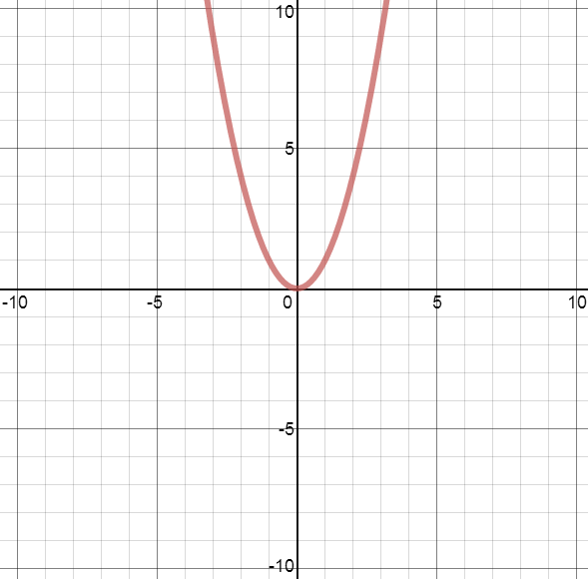

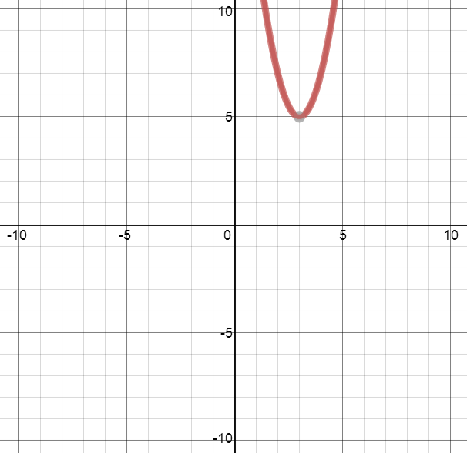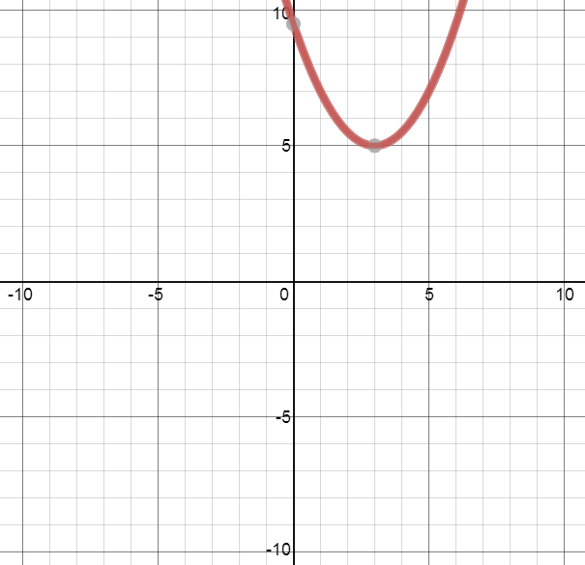

A) B)

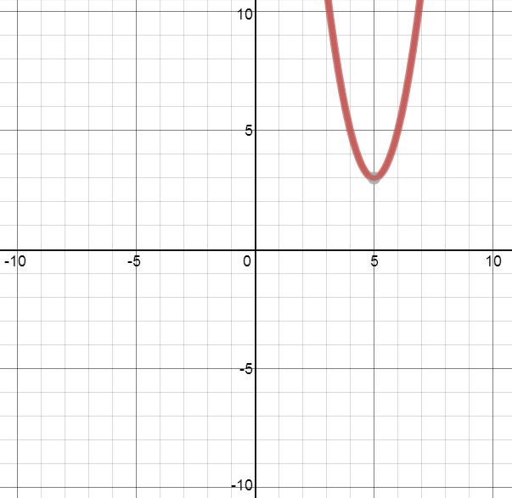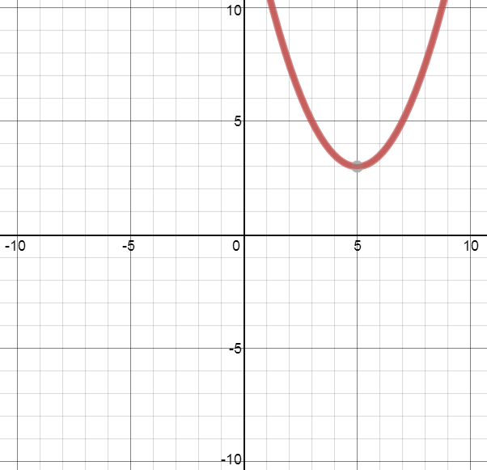C) D)

**For Questions 20 & 21, please refer to the example below.**

**An arrow is shot across a field into a target area on the ground in a competition. The model for the arrow’s trajectory can be used with the equation y = $-.3x^{2}+6x+15$.**

**20) After 10 seconds have passed, how high is the arrow in the sky?**

A) $≈$ 40 yards

B) $≈$ 45 yards

C) $≈$ 30 yards

D) $≈$ 25 yards

**21) How long will it be before the arrow finally strikes the ground?**

A) $≈$ 16 seconds

B) $≈$ 17 seconds

C) $≈$ 18 seconds

D) $≈$ 20 seconds

**Use the following function to answer question 22**

$$y=\frac{1}{2}F\left(x-3\right)+2$$

**22) Select the best description for the above function $.$**

A) Vertical stretch by ½ , Right 3, down 2

B) Vertical Compression by ½ , right 3, down 2

C) Vertical Compression by ½, right 3 and up 2

D) Vertical Compression by ½ , left 3 and up 2

**Solve the quadratic equation by completing the square.**

23) x2 – 12x = 38

A) 6 ± 74 B) -6 ± 4 2 C) 6 ± 4 2 D) -6 ± 74

24) x2 – 2x -24 = 0

A) 26, -24 B) -26 , 24 C) 6 , -4 D) -6, 4

25) (x + 3) 2 = 3

A) -3 ± 3 B) 3 ± 3 C) ±6 D) ± 6

Write the number as a product of the real number and i. Simply.

26)



27)



28)



29)



30)



Find the nonreal complex solutions of the equation.

31)



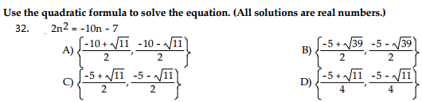

**Use the exponents rules in order to simply.**

33) x2 ● x3 =

A) X 6  B) x 5 C) x -1 D) x

34) 16y 7

8y

A) 2y7  B) 2y6  C) 8y 7 D) 8y6

35) (4x2 y3z0) 2

1. 8 x4 y6 B) 16 x4 y6 C) 16 x4 y5 D) 8 x4 y5
2. 
   1.  B)  C)  D) 

**Simplify the expression. Write the answer with positive exponents.**

37)

* 1.  B)  C)  D) 