Center and Spread of Data Practice Quiz #2 Name___________________________
1. The following numbers are test scores.
37 42 48 51 52 53 54 54 55

Mean: Mode: Range: 1st Quartile: 3rdQuartile: IQR:

Make a box and whisker plot for the data above. The 5 number summary will help.
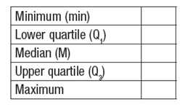
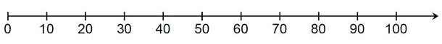
2. The following data are heights of the Enloe Basketball Team.
62, 64, 69, 70, 70, 71, 72, 73, 74, 75, 77

Mean: Mode: Range: 1st Quartile: 3rdQuartile: IQR:

Make a box and whisker plot for the data above. The 5 number summary will help.

3. Joy is ordering clothes online and tracks the amount of time they take to deliver.
1, 2, 2, 11, 4, 2, 3, 4, 5, 6, 2, 5, 1

Mean: Mode: Range: 1st Quartile: 3rdQuartile: IQR:

Make a box and whisker plot for the data above. The 5 number summary will help.

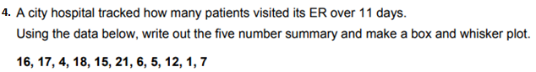

Mean: Mode: Range: 1st Quartile: 3rdQuartile: IQR:

Make a box and whisker plot for the data above. The 5 number summary will help.

