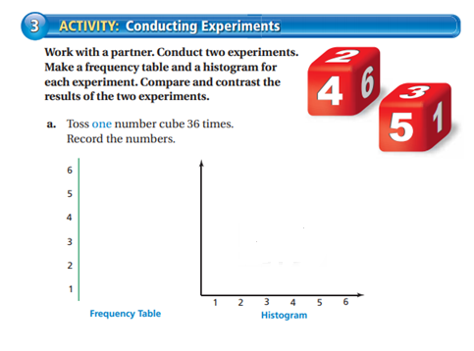
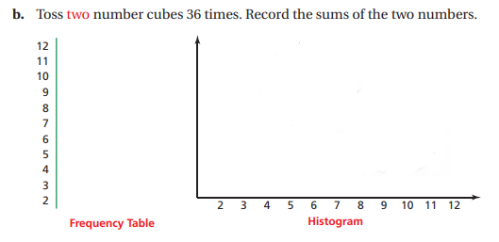
Describe the similarities or differences of a and b.(Use the words Shape, Center, Spread, Outliers)
_____________________________________________________________________________________

