Unit 2:Coord Transformations-Dilations Name:
Handout 4
In the previous investigation, you found patterns in the coordinates of preimage/image pairs for transformations with which you were familiar. As you complete the problems in this investigation, look for an answer to this question:
How can coordinates be used to rescale or resize a shape?
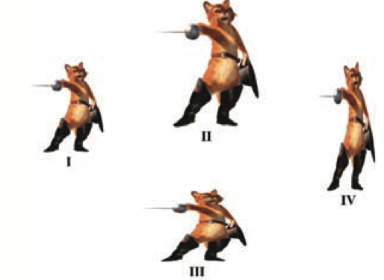
Problem 1:
Consider first the transformation defined by the following rule:
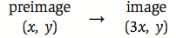
This rule is read “the x-coordinate of the image is 3 times the x-coordinate of the preimage; the y-coordinate of the image is the same as the y-coordinate of the preimage”

- Which of the figures II, III, or IV (above) appears to be the image of figure I under this transformation? Explain your reasoning.

- On a coordinate grid, plot the points X(1, 1), Y(5, 1), and Z(5, 5). Draw XYZ and its image under this transformation.
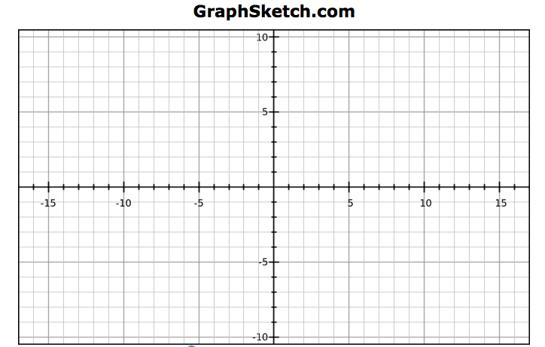
- Examine your preimage and image shapes. What characteristics of XYZ are also characteristics of its image? How do the shapes differ?

- How do you think the perimeter of XYZ will compare to the perimeter of its image? How do you think the area of XYZ will compare to the area of its image? Test your conjectures..

- Which of figures II, III, or IV (page 1) could be the image of figure I when transformed by the rule:
What clues did you use?

Your work on problem 1 has shown that even a simple transformation might not preserve all characteristics of the preimage shape. By modifying the transformation rule slightly, you can create a transformation which has many interesting and useful characteristics.

Problem 2:
A size transformation (or dilation) of magnitude 3 centered at the origin is defined by the following rule:
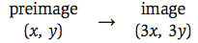
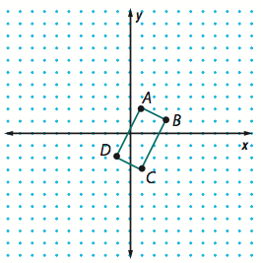
- On a copy of the diagram shown above, draw the image of quadrilateral ABCD under this size transformation. Label image vertices A’, B’, C’, and D’.

- Examine your preimage and image shapes. How are the perimage and image shapes similar? How are they different?

Problem 3:
Making visual comparisons, as you did in problem 2, is useful; but such comparisons should be made with some skepticism. You should always seek additional evidence to support or refute your visual conjectures. This is where coordinate representations and formulas for distance and slope can be very helpful. Use these ideas to examine more carefully quadrilateral ABCD and its image quadrilateral A’B’C’D’ that you drew in problem 2.
- Compare the length of AB with the length of A’B’. Does the same relation hold for other preimage/image pairs of the segments? Explain.

- How does AB appear to be related to AD? Does the same relationship hold for their images? Give evidence to support your claim.

- How do the perimeters of quadrilateral ABCD and quadrilateral A’ B’, C’, D’ compare?

- How does BC appear to be related to AD? Is this relationship true for their images? Justify your conclusion.
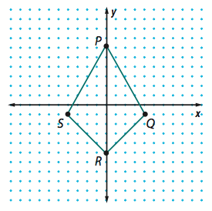
Problem 4:
Next, consider a size transformation with magnitude 0.5 and center at the origin.
- Write a rule for this size transformation.

- On a copy of the diagram shown here, plot and label the image of quadrilateral PQRS under this size transformation. How do you think quadrilateral PQRS and its image are related in terms of shape and size?

- Compare segment lengths in the image with corresponding lengths in quadrilateral PQRS. How does the magnitude 0.5 affect the relation between lengths and perimeters?

- Find the area of the image quadrilateral. Compare it to the area of quadrilateral PQRS. How does the magnitude 0.5 affect the relation between areas.

