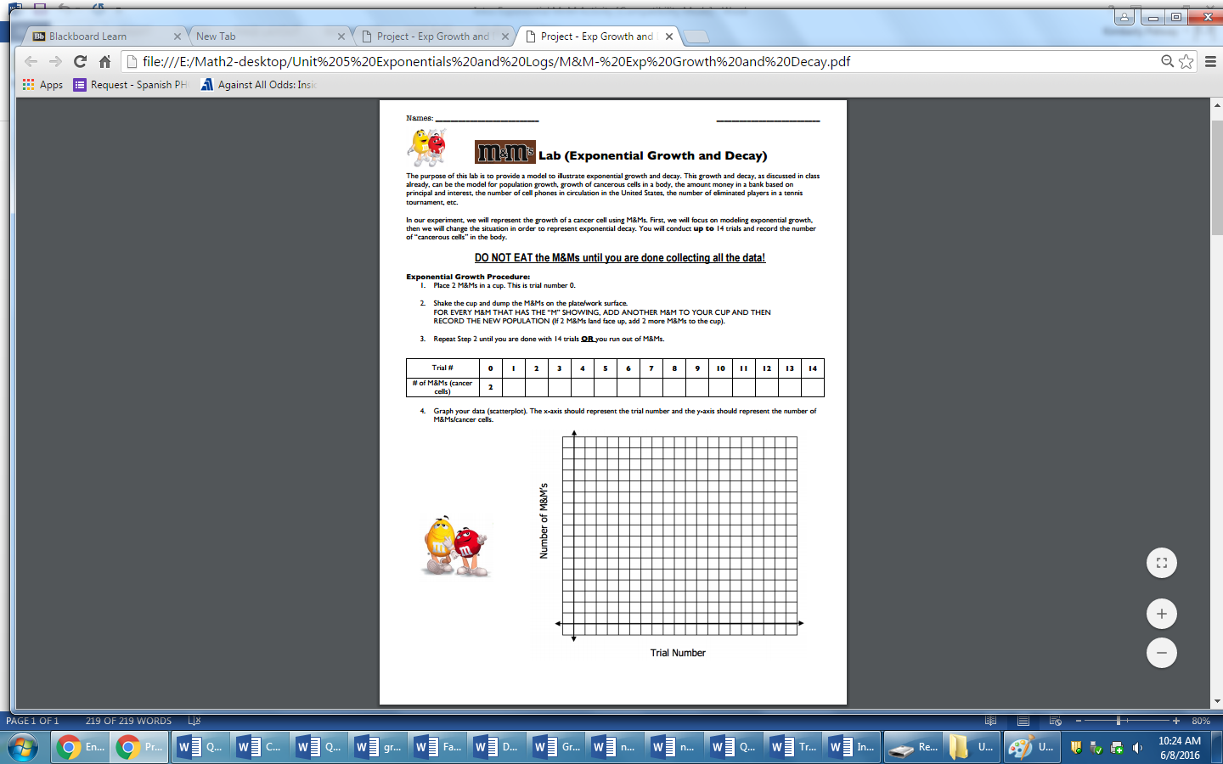

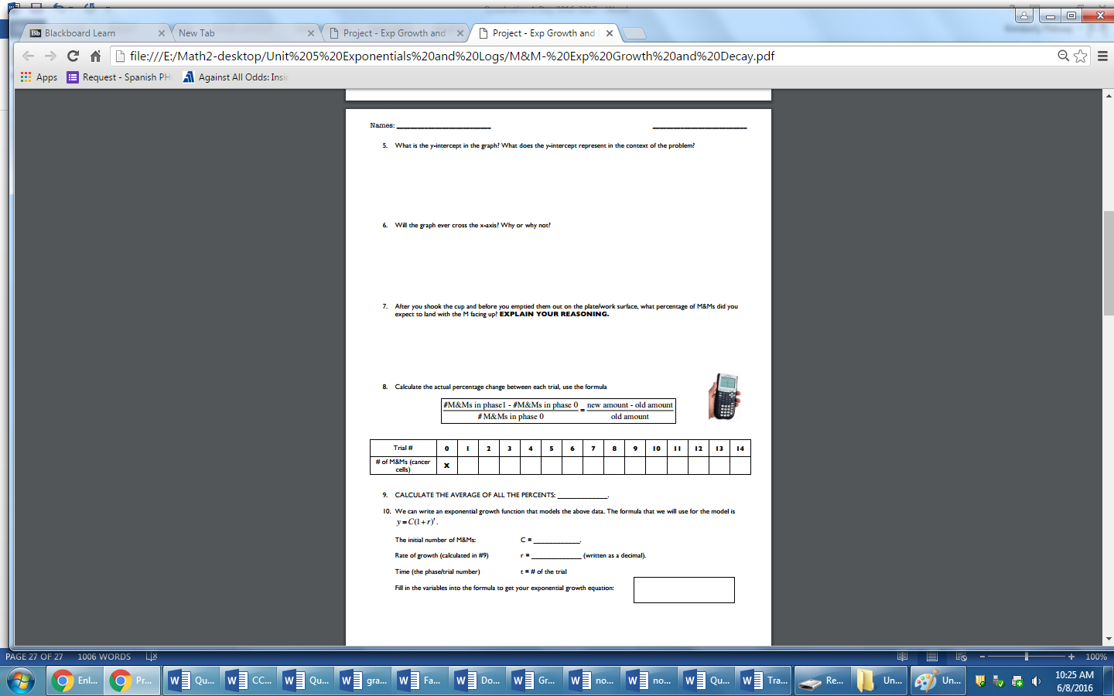

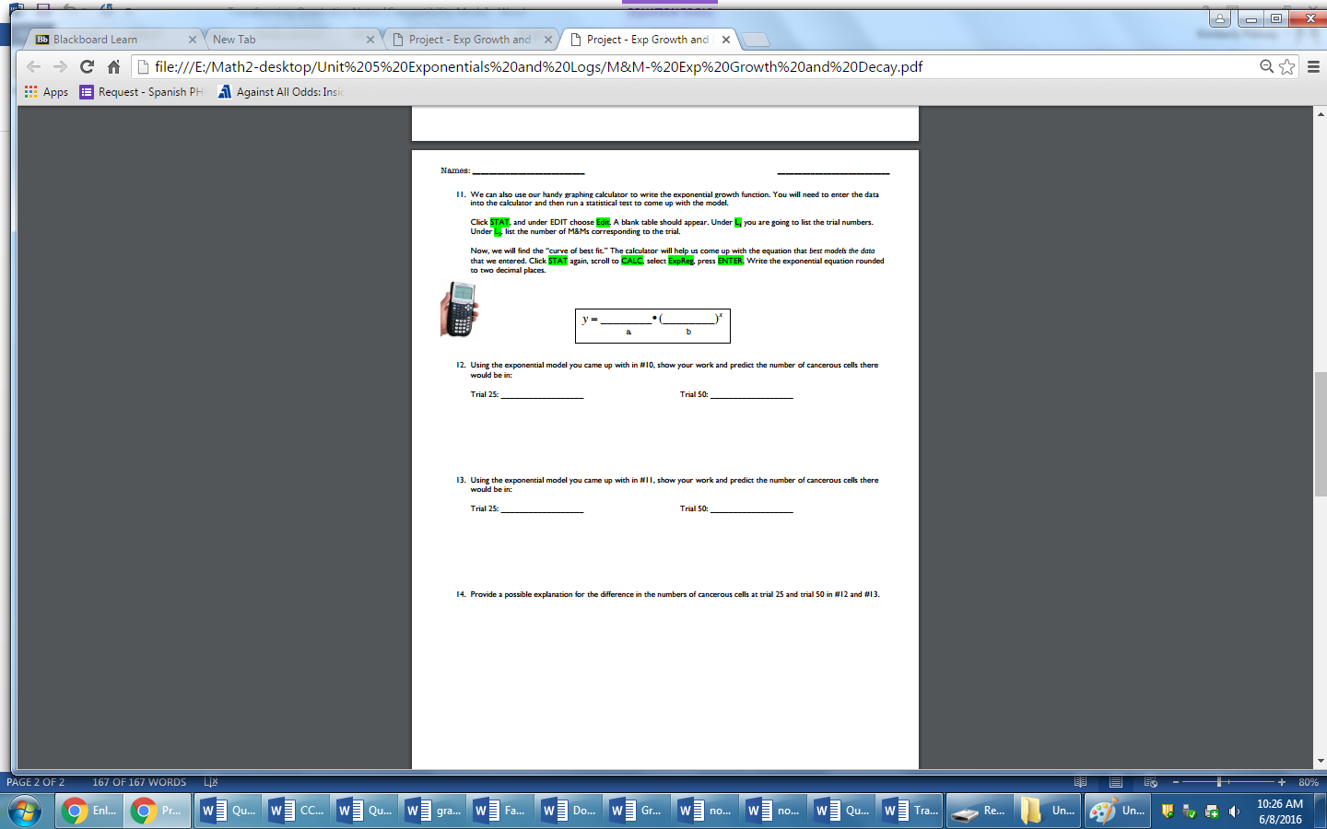

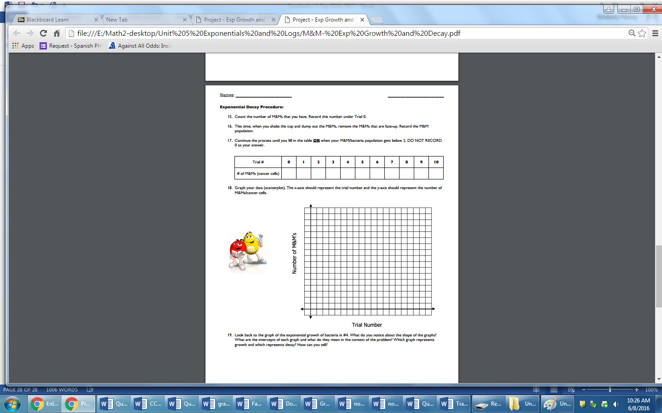

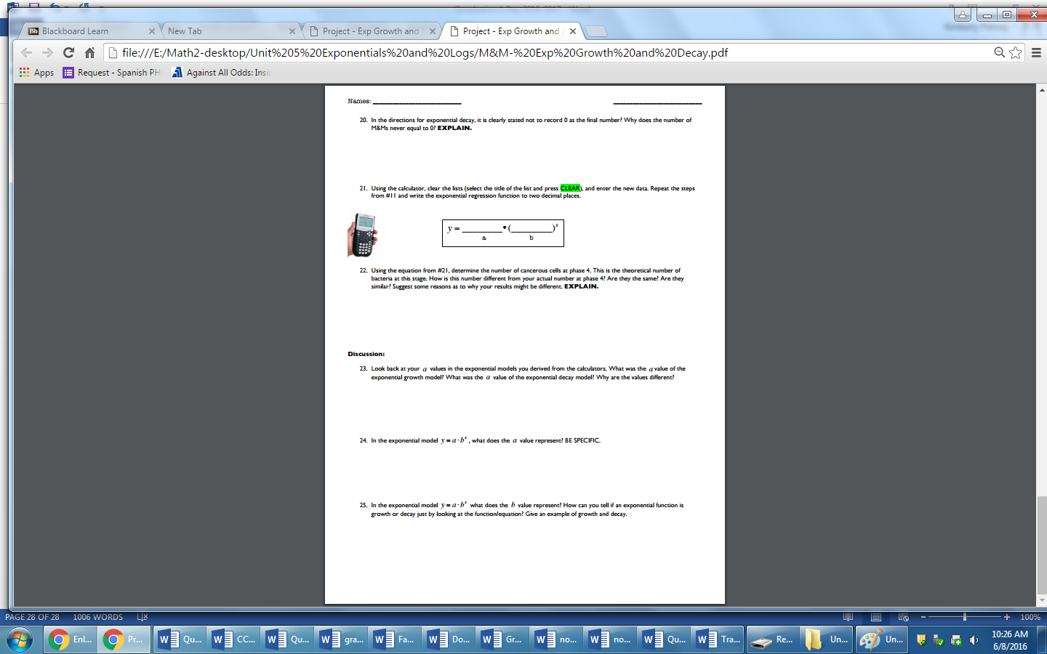

Common Core Math II Name Date

Guided Practice : Exponential Growth & Decay

1. You decide to conduct an investigation in a room of 100 standing students who were to randomly choose a number between and including 1 through 20. If they chose a multiple of 4, they were to sit down. You record the number of people still standing after each turn.
   1. What is the probability of choosing a multiple of 4?
   2. What is the common ratio for this investigation?
   3. What is the initial value of this investigation?
   4. Write a recursive equation for the investigation.
   5. Write an explicit equation for the investigation.
   6. Using your equations, how many stages of the investigation will occur before there are fewer than 3 people standing?
2. The amount of radioactive ore in a sample can be modeled by the equation $y=20{\left(0.997\right)}^{x}$, where x represents years and y is the amount of ore remaining in milligrams.
   1. What was the initial amount of radioactive ore?
   2. Is this an example of exponential growth or decay?
   3. What percentage of the ore is being lost or gained according to this model?
   4. When will there be half of the initial amount of the radioactive ore?
3. Complete the following table.

|  |  |  |  |  |
| --- | --- | --- | --- | --- |
| Explicit Function | Recursive Function | Initial Value | Common Ratio | Growth or Decay? |
| $$y=2{(3)}^{x}$$ |  |  |  |  |
|  | $$NEXT=NOW∙0.5, Start at-3$$ |  |  |  |
|  |  | 0.125 | 4 |  |
| $$y=ab^{x}$$ |  |  |  | growth |

1. The height of a plant can be modeled by the table below.

|  |  |  |  |  |  |
| --- | --- | --- | --- | --- | --- |
| Day | 0 | 1 | 2 | 3 | 4 |
| Height (in) | 2.56 | 6.4 | 16 | 40 | 100 |

1. What is the initial height of the plant? Explain how you found your answer?
2. What is the common ratio? Explain how you found your answer.
3. Is this an example of exponential growth or decay? How could you find the answer if you only had the common ratio?
4. Write the recursive function for this situation.
5. Write the explicit function for this situation.
6. How tall will the plant be on the 12th day of data collection? How tall is this in inches, feet, yards, and miles? Does this seem realistic to you?
7. On what day will the plant first be over 100 yards tall?
8. When you opened a savings account on your 15th birthday, you deposited most of the money from your summer job ($2000). The banker who helped you informed you that you would received 1.5% interest each year. How much money will you have in the account when you turn 21?
9. For each scenario, write an explicit equation, and define your variables.
10. The town of Braeford was first established in 1854 when it had a population of 24. Since then it has grown by a percentage of 1.25% each year.
11. A species of bacteria reproduces exactly once each hour on the hour. At this exact time, each organism present divides into two organisms. One of these bacteria is placed into a petri-dish at 8:00 this morning.

Common Core Math II Name Date

Independent Practice : Exponential Growth & Decay

**1POPULATION**

In 1990, Florida’s population was about 13 million. Since1990, the state’s population has grown about 1.7% each year. This means that Florida’s population is growing exponentially.

C:\Users\Diana\AppData\Local\Microsoft\Windows\Temporary Internet Files\Content.IE5\P5U78T3R\MC900156833[1].wmf

|  |  |
| --- | --- |
| Year | Population |
| 1990 |  |
| 1991 |  |
| 1992 |  |
| 1993 |  |
| 1994 |  |

1. Write an explicit function in the form $y=ab^{x}$ that models the values in the table.
2. What does x represent in your function?
3. What is the “a” value in the equation and what does it represent in this context?
4. What is the “b” value in the equation and what does it represent in this context?

**2 HEALTHCARE**

Since 1985, the daily cost of patient care in community hospitals in the United States has increased about 8.1% per year. In 1985, such hospital costs were an average of $460 per day.

1. Write an equation to model the cost of hospital care. Let x = the number of years after 1985.
2. Find the approximate cost per day in 2012.

C:\Users\Diana\AppData\Local\Microsoft\Windows\Temporary Internet Files\Content.IE5\UMQ1LOWD\MC900359059[1].wmf

1. When was the cost per day $1000

**3HALF-LIFE**

To treat some forms of cancer, doctors use Iodine-131 which has a half-life of 8 days. If a patient received 12 millicuries of Iodine-131, how much of the substance will remain in the patient 2 weeks later?

C:\Users\Diana\AppData\Local\Microsoft\Windows\Temporary Internet Files\Content.IE5\QT7UNX26\MC900389766[1].wmf

**4 SAVINGS**

Suppose your parents deposited $1500 in an account paying 6.5% interest compounded annually when you were born.

1. Find the account balance after 18 years.
2. What would be the difference in the balance after 18 years if the interest rate in the original problem was 8% instead of 6.5%?
3. What would be the difference in the balance if the interest was 6.5% and was compounded monthly instead of annually.

**5 HEALTH**

C:\Program Files (x86)\Microsoft Office\MEDIA\CAGCAT10\j0149627.wmfSince 1980, the number of gallons of whole milk each person in the US drinks in a year has decreased 4.1% each year. In1980, each person drank an average of 16.5 gallons of whole milk per year.

|  |  |
| --- | --- |
| Year | Population |
| 1980 |  |
| 1981 |  |
| 1982 |  |
| 1983 |  |
| 1984 |  |

1. Write a recursive function for the data in the table.

b) Write an explicit function in the form $y=ab^{x}$ that models the values in the table. Define your variables.

c) According to this same trend, how many gallons of milk did a person drink in a year in 1970?

C:\Users\Diana\AppData\Local\Microsoft\Windows\Temporary Internet Files\Content.IE5\UMQ1LOWD\MC900156911[1].wmf

**6 WASHINGTON, D.C.**

The model $y=604000{(0.982)}^{x}$ represents the population in Washington, D.C. $x$ years after 1990.

1. How many people were there in 1990?
2. What percentage growth or decay does this model imply?
3. Write a recursive function to represent the same model as the provided explicit function.
4. Suppose the current trend continues, predict the number of people in DC now.
5. Suppose the current trend continues, when will the population of DC be approximately half what it was in 1990?

Common Core Math II Practice Test Name____________________________________

1. You take one 1200mg dose of the medicine your doctor prescribed. Assume that your kidneys can filter out 30% of a drug every day.
   1. Make a table showing the amount of the drug remaining at various times.

|  |  |  |  |  |  |  |
| --- | --- | --- | --- | --- | --- | --- |
| Number of Days | 0 | 1 | 2 | 3 | 4 | 5 |
| Amount of Medicine | 1200 |  |  |  |  |  |

* 1. Write a short description of the pattern.
  2. Write an explicit equation that describe the amount of medicine in the blood.

y = ________________________________________________________

* 1. Use one of the rules in part c to estimate the amount of medicine left after 5.5 days.
  2. How long will it take the medicine to be reduced to only 1% (1 mg) of its original level in the body?

2. The sequence below shows the total number of bacteria in a Petri dish after n number of hours that started with 7 bacteria.

$$7, 14, 28, 56, …$$

Assuming the pattern continued, which function could be used to find the total number of bacteria at the end of *n* number of hours?

A. $f\left(n\right)=n+7$ B. $f\left(n\right)=2n$ C. $f\left(n\right)=7^{n}$ D. $f\left(n\right)={7\left(2\right)}^{n}$

**For problems 3-7**, use the following scenario. Each year the local country club sponsors a tennis tournament. Play starts with 128 participants. During each round, half of the players are eliminated.

3. If we were going to express the number of teams remaining in the tournament in a NOW-NEXT equation, what would that equation be?

A. B.

C. D.

4. What would the explicit equation be to predict the number of teams remaining, $y$, after a specific number of rounds,?

A. B. C. D.

5. If the numbers of teams remaining at the end of each round were represented as a sequence, would the sequence be arithmetic, geometric, or neither?

A. arithmetic B. geometric C. neither D.

6. How many rounds does it take to get a winner of the entire tournament, meaning there is 1 team remaining?

A. 5 rounds B. 6 rounds C. 7 rounds D. 8 rounds

7. In the context of the problem, does it make sense to have 10 rounds?

A. yes because you can continue the pattern forever if you wanted to get the # of teams

B. yes because you can put 10 into the equation and get an answer for the # of teams

C. no because the answer you get represents the # of teams and it isn’t possible

D. no because it is too hard

_____8. Which of the following sequences is created from the following information: ?

A. B.

C. D.

9. Jimmy conducted an experiment on the change in the population of a colony of bacteria based on a change in its surrounding temperature. He modeled the change in the population using the function $y=1000{\left(0.80\right)}^{x}$. Which of these statements is *true*?

A. The population decreases at a rate of 10%.

B. The population increases at a rate of 10%.

C. The population decreases at a rate of 80%.

D. The population increases at a rate of 80%.

10. Identify the correct characteristics of the following geometric sequence. $2,\frac{4}{3},\frac{8}{9},\frac{16}{27},\frac{32}{81}$

A. geometric, $d=3$ B. geometric, $r=3$ C. geometric, $d=\frac{2}{3}$ D. geometric,

11. When Diana was born, $5000 was put it into an account that gains 3.75% interest compounded monthly. Using the form $y=P{\left(1+\frac{r}{n}\right)}^{(nt)}$, how much would she have in her account after 18 years.

A. $14,203,676.34 B. $5,288.85 C. $5,190.76 D. $9,809.83

12. Samaj didn’t finish his homework assignment last night. He was supposed to write the first 2 terms of a geometric sequence that starts at 2. He wrote 2, 4 and did not finish. What are the next 3 terms of the sequence he was writing?

A. B. C. D.

13. Whitney wrote a compound interest equation for her sister, Rachel, to explain how their inheritance was growing in their account. Rachel understood most of the numbers in the equation but didn’t understand what the 2 meant. What does the number 2 mean in the equation $y=25000{\left(1+\frac{0.08}{2}\right)}^{2t}$?

A. compounded semiannually B. 2% interest C. initially had $2 D. 2 years

14. May bought a home for $125,000 in 2000. She learned that the area around her home increased the value of her home at a rate of 0.25% per year. Determine the value of her home in 2010.

A. $\$125,312.50$ B. $\$128,160.39$ C. $\$1,164,153.22$ D. $160,010.57

**For #15 – 20**, use the following equation:

15. Does the equation represent growth/decay?

A. growth B. decay

16. What is the initial value?

A. B. C. D.

17. What is the growth/decay factor?

A. B. C. D.

18. What is the rate of growth/decay?

A. B. C. D.

19. Find ?

A. B. C. D.

20. For what value of x is the function equal to ?

A. B. C. D.

21. The half-life of a radioactive substance is the length of time it takes for one half of the substance to dacay into another substance. To treat some forms of cancer, doctors use radioactive iodine. The half-life of iodine-131 is 8 days. A patient receives a 12-mCi (millicuries, a measure of radiation) treatment. How much iodine-131 is left in the patient 16 days later?

A. B. C. D.

22. Cesium-137 has a half-life of 30 years. Suppose a lab stored a 30-mCi sample in 1973. How much of the sample will be left in 2063?

A. $7.5$ mCi B. $15mCi$ C. $3.75$ mCi D. mCi

23. The half-life of iodine-124 is 4 days. A technician measures a 40-mCi sample of iodine-124. How many half-lives of iodine -124 occur in 16 days?

A. B. C. D.

24. The half-life of carbon-11 is 20 minutes. A sample of carbon-11 has 25mCi. How much carbon-11 is in the sample 1 hour after the original sample is measured?

A. $3.125mCi$ B. $24.14$ mCi C. $23.33$ mCi D. $3$ mCi

Growth, Decay, Inverses, Exponentials and Logarithms Practice Test

1. The half-life of a radioactive substance is the length of time it takes for one half of the substance to decay into another substance. To treat some forms of cancer, doctors use radioactive iodine. The half-life of iodine-131 is 8 days. A patient receives a 12-mCi (millicuries, a measure of radiation) treatment. How much iodine-131 is left in the patient 16 days later?

2. The half-life of carbon-11 is 20 minutes. A sample of carbon-11 has 25 mCi.

a. How many half-lives of carbon-11 occur in 1 hour?

b. How much carbon-11 is in the sample 2 hours after the original sample?

3. Cesium-137 has a half-life of 30 years. Suppose a lab stored a 30-mCi sample in 1973. How much of the sample will be left in 2063?

4. Find the value of $10,000 invested at 5% compounded quarterly for 5 years.

5. In 1990, the population of Washington, D.C. was about 604,000 people. Since then the population has decreased about 1.8% per year. If this trend continues, predict the population of Washington, D.C. in 2020.

6. Given the function y = - (10 x-2)– 3. Describe the transformation(s).

7. Find the inverse for the following functions.

a. y = x2 – 5 b. y = c. y = 2x – 4

Solve for x.

8. 5 log (x) = 20 9. – log ( x + 5) = 3