Features of Functions book page 5 (you are using the computer to find answers to 15-22)
- Use Google Chrome and type in Desmos.com
- Click on the red tab – Start Graphing
- Click on the keyboard that looks like at the bottom of the screen.

- In the box that looks like the example below, type in y = 10

- Click on the a^{b} button on the expanded keyboard and type x ( you should see y= 10^{x}
- Press enter and another box should appear where you can type in y = 100000
- Once you have done these things correctly you should have the following on your screen.
- 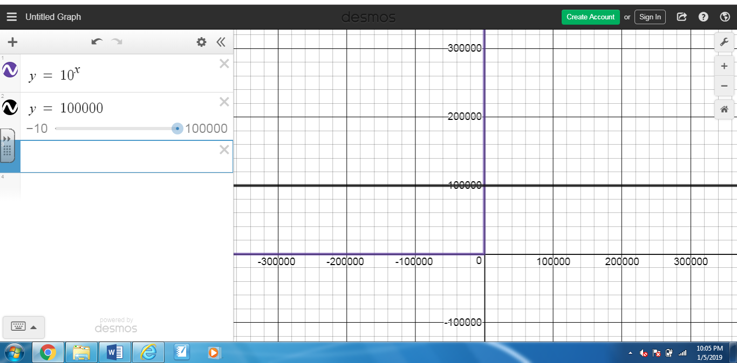

- You want to find out where the points intersect, so you may need to zoom out in order to find the intersection.
- The zoom out button is to the far right and looks like a subtraction sign.
- Click on the place where the lines intersect and write down the solution to #14 in your book. (The x value)
- Clear the information you typed in boxes 1 and 2
- Type y = 3x + 7 in box 1
- Type y = 5x -21 in box 2
- Now two lines should be graphed. Find the point where these lines intersect by scrolling upwards on the graph.
- Click where the lines intersect and write the solution under #15 in your book
- Type y= -6x – 15 in box 1
- Type y = 4x + 35 in box 2
- Find the point of intersection of those lines and write down the solution under #16 in your book
- Type y= 5x – 8 in box 1
- Type y = 37 in box 2
- Find the point of intersection of those lines and write down the solution under #17 in your book
- Type y= 3^{x} (Remember to press in order to get the exponent )
- Type y = 81 ( ZOOM IN to find the intersection of these lines)
- Find the point of intersection of those lines and write down the solution under #18 in your book
- Type y= 3x – 12 in box 1
- Type y = -4x +23 in box 2
- Find the point of intersection of those lines and write down the solution under #19 in your book
- Type y= 10 in box 1
- Type y = 2^{x}- 22 in box 2
- Find the point of intersection of those lines and write down the solution under #20 in your book
- Type y= 243 in box 1
- Type y = 8x + 3 in box 2
- Find the point of intersection of those lines and write down the solution under #21 in your book
- Type y= 5^{x} - 7 in box 1
- Type y = 118 in box 2
- Find the point of intersection of those lines and write down the solution under #22 in your book

Features of Functions book page 9 (you are using the computer to find answers to 1-6)

You will continue to use Desmos, but your solution will contain both the x and y value. (x,y)

- Clear the information you typed in boxes 1 and 2
- Type y = 2x - 7 in box 1
- Type y = -4x + 5 in box 2
- Click where the lines intersect and write both the x and y values by #1
- Type y= -5x – 2 in box 1
- Type y = -2x + 1 in box 2
- Find the point of intersection of those lines and write down the solution under #2 in your book
- Type y= -x – 2 in box 1
- Type y = 2x + 10 in box 2
- Find the point of intersection of those lines and write down the solution under #3 in your book
- Type y= x – 5 in box 1
- Type y = -x + 1 in box 2
- Find the point of intersection of those lines and write down the solution under #4 in your book
- Type y= 2/3x + 4 in box 1 ( remember the fraction bar / is division )
- Type y = -1/3x + 1 in box 2
- Find the point of intersection of those lines and write down the solution under #5 in your book
- Type y= x in box 1
- Type y = -x- 2 in box 2
- Find the point of intersection of those lines and write down the solution under #6 in your book
_________________________________________________________________
- Go to desmos.com
- Click on classroom activities
- On the left side of the screen, click on Functions
- Under 1, click on function carnival
- Scroll down to the rocket ship and play the video.
- Draw a draw that fits the Cannon Man’s height v. time

Relation – a set of ordered pairs ex. (18, 4.25)(20, 4.4)(21, 5.25)(14, 5)(18,4.85)
Domain-x values in a relation ex.The domain for the relation above: {14,18,20,21}
Range – y values in a relation
ex. The range for the relation above:{4.25,4.4,4.85,5, 5.25}
Function – a relation that assigns exactly one value in the range to the value in the domain. ( For every x value there is only one y value; x value does not repeat)

Function or Not a Function?
3
-1
5
8

2
7
x | y
-1 | -2
-2 | -3
-3 | -4
-4 | -4
-5 | -6
x | y
3 | -1
3 | 0
4 | -1
4 | 2
5 | 0
x | y
-1 | 3
-1 | 4
-1 | -2
-1 | 2
-1 | 0
{(5,1), (-1,5), (-5,1), (1,-5), (5,3)}
{(-3,0), (-2,0), (-1,0), (0,0), (1,0)}
{(1,4), (3,2), (-3,-2), (1,2), (-2,-3)}
x | y
1 | -2
4 | -3
6 | -4
8 | -4
1 | -6

