7

-1/3
3

-3/2

Find the slope.

(9, 18) (9, 20)

Undefined
5/3
7/3

-3
¾

Find the slope.
(19,-16)
(-7, -15)

-1/26

Find slope
(20,8) (9,16)

-8/11

Find slope
(-4, 7)(-6,-4)

11/2

Find slope.
(3, 0)(-11, -15)

15/14

Find the slope
(12, 2) (-7, 5)

-3/19

Find the slope.
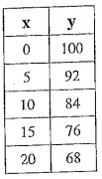
8/5

Find the slope
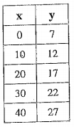

½

Find the slope.
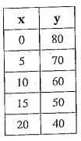
-2

Find the slope.
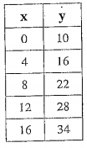

3/2

Find the slope.
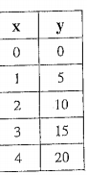
5

Find the slope
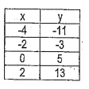
4

Find the slope.
7x – y = 8

