Geometry Terms and Definitions
For each term below, give the definition and an example.
Term | Definition | Example
Point
Line
Line Segment
Midpoint
Ray
Perpendicular Lines
Parallel Lines
Angle
Acute Angle
Obtuse Angle
Right Angle
Triangle Sum Theorem
Adjacent Angles
Straight Angle
Straight Angle Addition
Vertical Angles
Alternate Interior Angles
Complementary Angles
Supplementary Angles
Corresponding Angles
Alternate Exterior Angles
Obtuse Triangle
Acute Triangle
Right Triangle

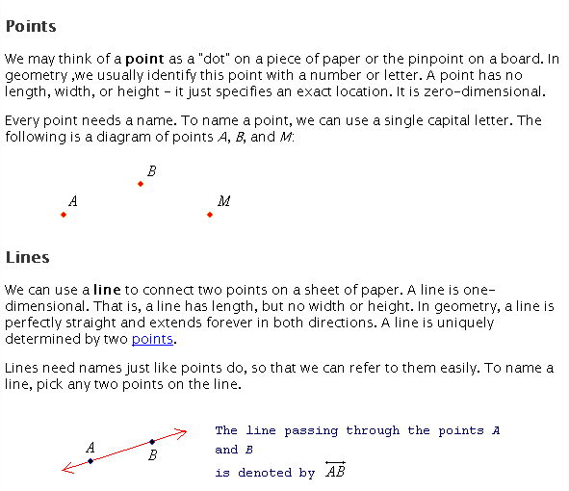

Perpendicular Lines
Two lines are perpendicular if they make 90º angles.
Parallel Lines
Two lines are parallel if they never intersect. We mark lines are parallel with arrows

Can you create the rules for Congruence…

Name: _______________________________ Date: ____________________

SSS Congruency:
For example look at the following two triangles:
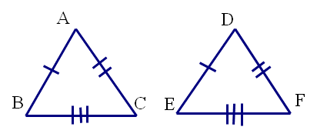

What can you determine from these two triangles?

Explain how you reached this conclusion. What parts of the triangles did you have to look at to compare?

We can use this information to create rule for all triangles with this given information.

Remember: In math, we often times call rules “Postulates” or “Theorems”

SSS-Congruency Postulate:
If the sides of one triangle are to the sides of the second triangle, then the triangles are congruent. To write this we use the notation:

By SSS congruency

ASA Congruency:
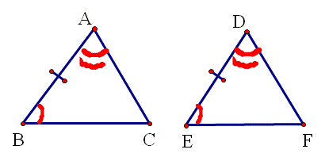
For example look at the following two triangles:

What can you determine from these two triangles?

Explain how you reached this conclusion. What parts of the triangles did you have to look at to compare?

We can use this information to create rule for all triangles with this given information.

Remember: In math, we often times call rules “Postulates” or “Theorems”

ASA-Congruency Postulate:
If two angles and the of one triangle are to the two angles and the included side of another triangle, then the triangles are . To write this we use the notation:

By ASA congruency

SAS Congruency:
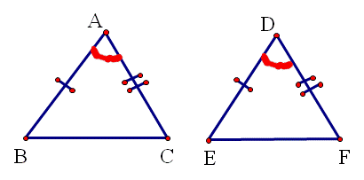
For example look at the following two triangles:

What can you determine from these two triangles?

Explain how you reached this conclusion. What parts of the triangles did you have to look at to compare?

We can use this information to create rule for all triangles with this given information.

Remember: In math, we often times call rules “Postulates” or “Theorems”

SAS-Congruency Postulate:
If two sides and the of one triangle are to the two sides and the included angle of another triangle, then the triangles are . write this we use the notation:

By SAS congruency

State if the following triangles are congruent using the postulates we know so far. If they are congruent, state which postulate applies (SSS, SAS, ASA)
