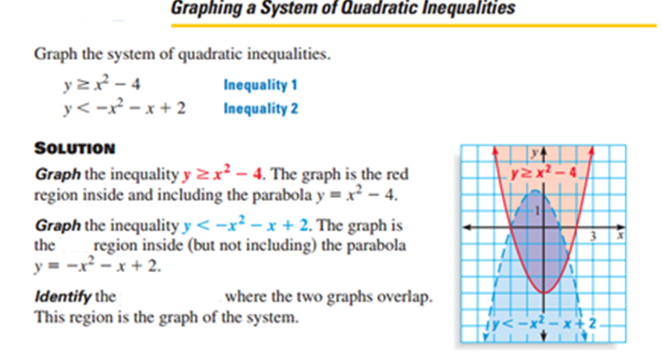

Graph and shade the solution region.

1.  2. 

 

3.  4. 

 

1. The Empire State Building is 1250 feet tall. If an object is thrown upward from the top of the building at an initial velocity of 38 feet per second, its height s seconds after it is thrown is given by the function h(s) = -16s2 + 38s +1250. How long will it take for the ball to hit the ground?

2. A juggler throws a ball into the air, releasing it 5 feet above the ground with an initial velocity of 15 ft/sec. She catches the ball with her other hand when the ball returns to 5 feet above the ground. If the equation h = -16t2 + 15t gives the path of the ball from hand to hand, find how long the ball is in the air.

3. A ball is thrown straight up with an initial velocity of 56 feet per second. The height, h, of the ball t seconds after it is thrown is given by the formula h(t) = 56t – 16t2

a) What is the maximum height?

b) What is the height of the ball after 1 second?

c) After how many seconds will it return to the ground?

4. A ball is thrown upward from the ground. Its height (h, in feet) is given by the function h=-16t2 + 64t +3, where t is the length of time (in seconds) that the ball has been in the air. What is the maximum height that the ball reaches?

5. The height, h(t), in feet, of an object shot from a cannon with initial velocity of 20 feet per second can be modeled by the equation h(t) = -16t2 + 20t + 6, where t is the time, in seconds, after the cannon is fired. What is the maximum altitude that the object reaches?

6. Physicists tell us that altitude h in feet of a projectile t seconds after firing is h = -16t2 + vot + h0, where vo is the initial velocity in feet per second and ho is the altitude in feet from which it is fired. If the rocket is launched from a hilltop 2400 feet above the desert with an initial upward velocity of 400 feet per second, when will it land on the desert?

7. The engind torques y (in foot –pounds) of one model of car is given by y = -3.75x2 + 23.2x + 38.8 where x is the speed of the engine ( in thousands of revolutions per minute).

a) Find the engine speed that maximizes the torque.

b) What is the maximum torque?

8. In baseball, the flight of a pop-up may be described as d= -16t2 + 80t + 3.5 where d gives the ball’s height above the ground in feet as a function of time t. How long does the catcher have to get into position under the ball after the ball is hit?

9. When a gray kangaroo jumps, its path through the air can be modeled by y = -0.0267x2 + 0.8x where x is the kangaroo’s horizontal distance-traveled (in feet) and y is the corresponding height (in feet).

a) How high can a gray kangaroo jump?

b) How far can it jump?