Common Core Math II Name Date
Square Root Function

The parent square root function is:
$$y=\sqrt{x}$$

As with all other functions we have learned, square root functions can be transformed.

Key Features of Square Root Functions

Characteristic Points for $y=\sqrt{x}$

Domain:

Range:

Intercept:

Fill in the table below with a description of what happens to the parent function when the following transformations are performed.
Parent Function | $y=\sqrt{x}$

Description | Transformation
 | $$y=\sqrt{x+h}$$
 | $$y=\sqrt{x-h}$$
 | $$y=\sqrt{x}+k$$
 | $$y=\sqrt{x}-k$$
 | $$y=-\sqrt{x}$$
 | $$y=a\sqrt{x}$$

Let’s look at the following example.
The graph on the right represents a transformation of the graph of
$y=-3\sqrt{x}$
The description is as follows:

Domain:

Range:

The graph on the right represents a transformation of the graph of
$y=-3\sqrt{x-2}+1$
The description is as follows:

Domain:

Range:

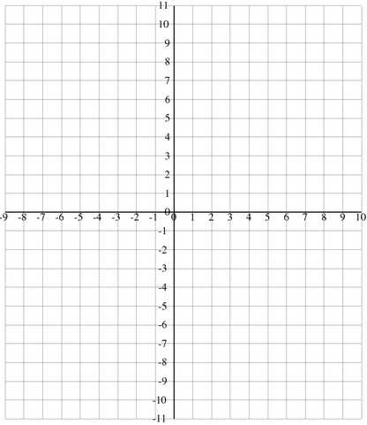
TRY NOW
Graph the following function on the graph at right. Describe each transformation, give the domain and range, and identify any asymptotes.

$y=0.5 \sqrt{x-3}+2$

Description:

Domain:

Range:

Common Core Math II Name Date
Cube Root Function

The parent cube root function is:
$$y=\sqrt[3]{x}$$

As with all other functions we have learned, cube root functions can be transformed.

Key Features of Cube Root Functions
Characteristic Points for $y=\sqrt[3]{x}$

Domain:

Range:

Intercept:

Fill in the table below with a description of what happens to the parent function when the following transformations are performed.
Parent Function | $$y=\sqrt[3]{x}$$

Description | Transformation
 | $$y=\sqrt[3]{x+h}$$
 | $$y=\sqrt[3]{x-h}$$
 | $$y=\sqrt[3]{x}+k$$
 | $$y=\sqrt[3]{x}-k$$
 | $$y=-\sqrt[3]{x}$$
 | $$y=a\sqrt[3]{x}$$

Let’s look at the following example.
The graph on the right represents a transformation of the graph of
$y=3\sqrt[3]{x}$
The description is as follows:

Domain:

Range:

The graph on the right represents a transformation of the graph of
$y=3\sqrt[3]{x+2}-1$
The description is as follows:

Domain:

Range:

Now it’s your turn to find key features and translate logarithmic functions.

TRY NOW
Graph the following function on the graph at right. Describe each transformation, give the domain and range, and identify any asymptotes.

$y=0.5\sqrt[3]{x-1}+3$
Description:

Domain:

Range:

Core 2 Name___________________________________

Graphing Square and Cube Root Functions

Identify the domain and range of each. Then sketch the graph.

1) y = x + 4
3) y = 3 + x + 3
5) y =
x
7) y = x − 1
9) y = 3 + x − 2
3
11) y = −5 + x
3
13) y = x
3
15) y = x + 3
3
17) y = x + 3 − 1

3
19) y = x + 5
2) y = − x − 3
4) y = − x − 1 − 3
6) y = x − 2 + 1
8) y = x − 2 + 2
10) y = x + 4
3
12) y = x − 3
3
14) y = x + 4
3
16) y = x − 2 − 3
3
18) y = 64x
3
20) y = 2 x − 4

©f G2B0t1T35 aKKuBtFaI uSxoUfGtLwYaOrKeU 9LdL2Cw.g v xAUlzlu 9r7i0gthZt6sY vrDeXsxeTrEvyeidC.l O kMBaadTeY bwUihtthn oIQnNfTijnlintges GAvlkgAeZbZr1a6 K2b.p
Answers to Graphing Square and Cube Root Functions

1) 2)
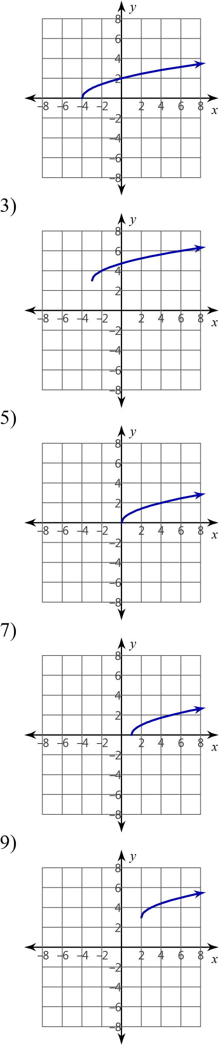
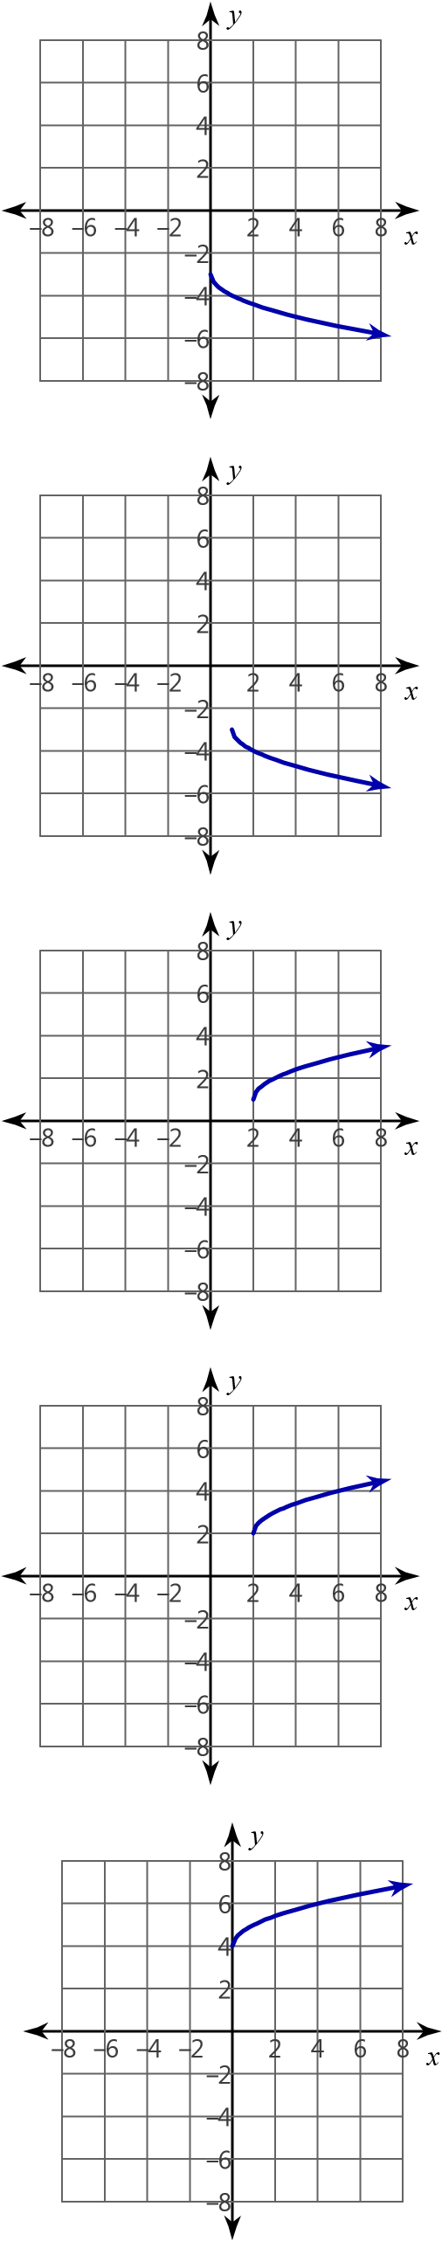
Domain: x ≥ −4 Domain: x ≥ 0
Range: y ≥ 0 Range: y ≤ −3

4)
Domain: x ≥ −3 Domain: x ≥ 1
Range: y ≥ 3 Range: y ≤ −3

6)
Domain: x ≥ 0 Domain: x ≥ 2
Range: y ≥ 0 Range: y ≥ 1

8)
Domain: x ≥ 1 Domain: x ≥ 2

