Investigate!!!!
Rotations about the origin have similar coordinate models. A rotation, or turning motion, is determined by a point called the center of rotation and a directed angle of rotation. A flag ABCDE and its images under counterclockwise rotations of 90°, 180°, and 270° about the origin are shown below.
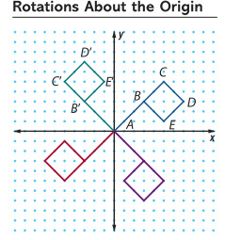
Problem 1:
Consider flag ABCDE above and its image under a 90° counterclockwise rotation about the origin.
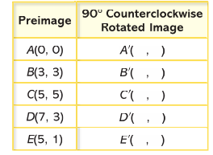
- On a copy of the table below, record the coordinates of the images of the five points on the flag under a 90° counterclockwise rotation about the origin.

Is there a pattern that you see between the original image and the 90° counterclockwise rotation about the origin? Be sure to explain using only the rotated images of points A, B, C, D, and E.

- Use any patterns you see between preimage and image points in your completed table in part a to help plot the points (-2, -5), (-4, 1), (5, -3), and their images under a 90° counterclockwise rotation about the origin on a new coordinate grid. Be sure to label each pre-image point and image point.
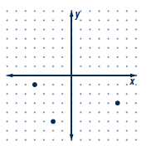
- Write a rule relating the coordinates of any preimage point (x,y) and its image point under a 90° counterclockwise rotation about the origin. State your rule in words and in symbolic form.
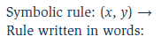

- According to your rule, what is the image of (0,0)? Why does this image make sense?

Problem 2:
As you probably expect, counterclockwise rotations of 180° and 270° about the origin also have predictable coordinate patterns. Use the graphs of flag ABCDE from the previous problems to explore these patterns (the graph below).
- Investigate patterns in the coordinates of the preimage and image pairs when points are rotated 180° about the origin.
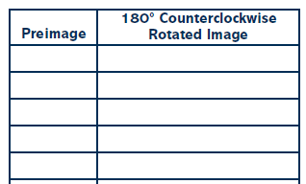
Is there a pattern that you see between the original image and the 180° counterclockwise rotation about the origin?

- Write a rule relating the coordinates of any preimage point (x,y) and its image point under a 180° rotation about the origin. State your rule in words and in symbols.
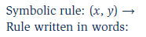

- Similarly, search for patterns in the coordinates of the preimage and image pairs when points are rotated 270° counterclockwise about the origin.
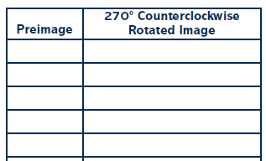
Is there a pattern that you see between the original image and the 270° counterclockwise rotation about the origin?

- Write a rule relating the coordinates of any preimage point (x,y) and its image point under a 270° counterclockwise rotation about the origin. State your rule in words and in symbols.
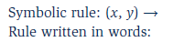

Problem 3:
- Take a look at the rotations in Problems 1 and 2. What type of rotation would a 90° Clockwise rotation be identical to?

- Write a rule relating the coordinates of any preimage point (x,y) and its image point under a 90° clockwise rotation about the origin. State your rule in words and in symbols.

- What type of rotation would a 180° Clockwise rotation be identical to?

- Write a rule relating the coordinates of any preimage point (x,y) and its image point under a 180° clockwise rotation about the origin. State your rule in words and in symbols.

- What type of rotation would a 270° Clockwise rotation be identical to?

- Write a rule relating the coordinates of any preimage point (x,y) and its image point under a 270° clockwise rotation about the origin. State your rule in words and in symbols.

