CCMII Graphing and Understanding Sine, Cosine and Tangent
- Sine Graph

- Sine is increasing: c. Sine is positive:
- Sine is decreasing: d. Sine is negative:

- Cosine Graph

- Cosine is increasing: c. Cosine is positive:
- Cosine is decreasing: d. Cosine is negative:

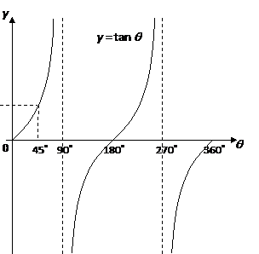
- Tangent Graph

- Tangent is increasing: c. Tangent is positive:
- Tangent is decreasing: d. Tangent is negative:

Graphing Sine and Cosine (by hand) TEACHER KEY
- Sine Graph
Maximum
Complete Period
Midline

Minimum

(0,180)
(0,90) U (270,360)
- Sine is increasing: c. Sine is positive:
(180,360)
(90,270)
- Sine is decreasing: d. Sine is negative:

- Cosine Graph
Maximum

Complete Period

Midline

Minimum

(180,360)
- Cosine is increasing: c. Cosine is positive:
(90,270)
(0,90) U (270,360)
(0,180)
- Cosine is decreasing: d. Cosine is negative:
- Tangent Graph
Asymptote

Midline

(180,360)U(180,270)
(0,90)U(90,180)U(270,360)
- Tangent is increasing: c. Tangent is positive:
never
- Tangent is decreasing: d. Tangent is negative:
(90,180)U(270,360)

