- Solve: $2x+3x+7= -41$ | - Solve: $2\left(m+1\right)=16$
- Solve: $\frac{1}{3}x=\frac{1}{2}$ | - Solve: $4x+3=2x-5$
- Write and solve an equation for the following:  A hawk can fly at 30 miles/hour. How far will the hawk travel in 20 minutes? | - Solve: $\frac{x}{4}=\frac{7}{8}$
- Find the next three terms of the sequence and write an explicit formula:  4, 12, 36, 108, … | - Write a rule for the sequence:  2, 20, 200, 2000, …
- Find the 3rd term in the sequence:  $$A\left(n\right)=3{\left(4\right)}^{n-1}$$ | - Find the next three terms of the sequence and write an explicit formula.  100, 95, 90, 85, …
- Write a rule for the sequence:  17, 22, 27, 32, … | - Find the 4th term in the sequence:  $$A\left(n\right)=-12+4(n-1)$$
- Using the formula, $y=a{\left(1+r\right)}^{n}$  Find the value of a $10,000 invested at 4% for 10 years. | - Using the function, $P(t)=a{\left(1+r\right)}^{t}$,  Calculate the population of Apex, NC in ten years if their current population is 150,000 people and the town grows at a rate of 3% each year.
- Using the function, $P(t)=a{\left(1+r\right)}^{t}$,  Calculate the population of Beaufort, NC in ten years if their current population is 110,000 people and the town decreases at a rate of 2% each year. | - Sam is saving $20 each week from his job. He has $300 in savings right now. Write an equation to model how much money he will have in “x” weeks.
- Find the slope of a line that passes through points (1,4) and (2,10). | - Write the equation of a line that passes through point (0,4) with a slope of -4.
- Write the equation of a line that passes through points (1,5) and (3,15). | - Find the equation of a line from the following table. What is the y-intercept? What is the slope?  x y  0 12  1 9  2 6  3 3
- Graph the line: $y=2x-1$ | - Graph the equation: $y=3^{x}$
- 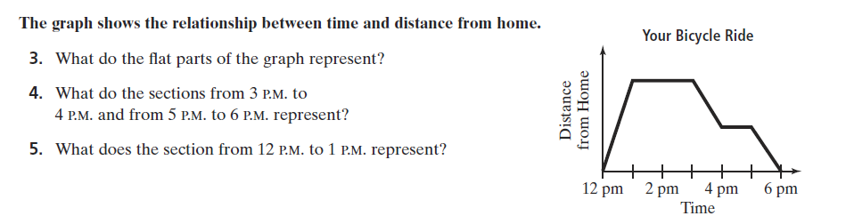
- Is the relation a function?  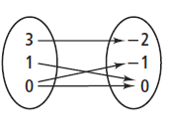 | - Is the relation a function?  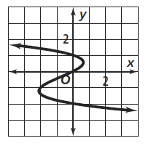
- State the domain, range, x-intercept, y-intercept, intervals where the function is increasing and decreasing.  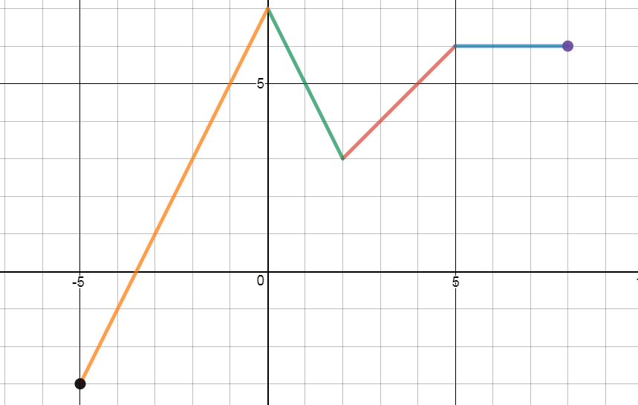 | - Use the graph to answer the following questions:  - What is f(-4)?  - What is f(6)?  - What is g(-2)?  - What is g(0)?  - f(-4)+g(0)=?  - f(6) – g(-2)=?  - Where is g(x)>f(x) 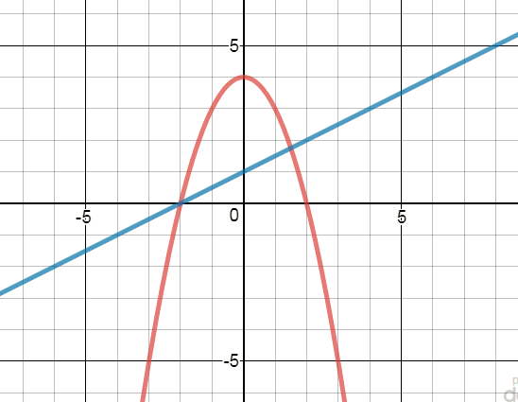
- $f\left(x\right)=4x-5, find f(2)$ | - $g\left(x\right)=-3x+5, find x when g\left(x\right)=14$
- The distance a sloth can travel is a function of time. If sloths move at a constant rate of 6 feet/minute, how many minutes would it take a sloth to travel 20 feet? Write and solve an equation.

