Function Practice Problems
- How can you tell whether or not a relation is a function? How can you tell a whether or not a graph is a function?

- The function $f\left(x\right)=0.6x+2.75$ models the cost of a container of cream cheese and x bagels.
What is the cost of 12 bagels?

How many bagels can be purchased with $30?

- Find $f\left(-2\right)$ if$f\left(x\right)=7x+5$. Show your work.

- Find the value of x for when $f\left(x\right)=9$, if $f\left(x\right)=3x+15$. Show your work.

- Tell whether or not the following relations are functions.
  - $\left\{\left(0,4\right), \left(3,7\right), \left(4,3\right)\right\}$

  - $\left\{\left(-1,3\right), \left(0,3\right), \left(-1, 4\right)\right\}$

  - $\left\{\left(2,3\right), \left(4,-1\right), (0,5)\right\}$

- At what intervals is the graph:
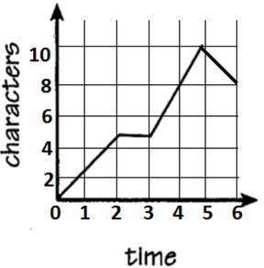
  - Increasing

  - Decreasing

  - Constant

Find the domain of the given function: $\left\{\left(-1,0\right), \left(2,3\right), \left(3,4\right), (5,6)\right\}$

Linear Practice Problems
- The function f(x) = 5x +12 models the time in minutes that a customer will wait to get a learners permit if there are x people ahead of the customer.
A)How long will a customer wait if they are the tenth person in line?

b) what is the slope and what does it represent in this problem?

c) Graph the function.

- What is the total perimeter of the 12th diagram in the following pattern?
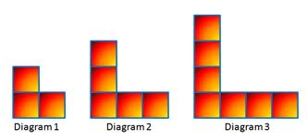

N = 1  P = 8 | N = 2  P = 12 | N = 3  P = 16

- Write the equation of the line that contains points (-2, 8) and (1, 2) in
- Slope intercept form
- Point-slope form
- Standard form

4. Consider the sequence shown below.
-3, -6, -9, -12, …..
Write a NEXT / Now equation to represent this sequence.

5. To find the slope of the line between the points (13, -5) and (7,- 2), Michelle writes the following:
-5 – (-2)
7 - 13
What mistake did Michelle make?

6. Find the rate of change from the graph below.
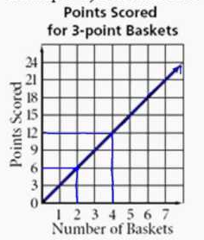

Quarter Retake Questions: Systems of Equations
Practice:
The Browns scored 13 more points than the Saints. The total of their scores was 47. How many points did each time score? Solve using the method of your choice (elimination, substitution or graphing)

When solving a system of equations, what does the solution represent?

If there is no solution to a system of linear equations then the graph of the system contains (what type of lines)?

Is the given point a solution to the system, yes or no?
3x – y = 4 (1, -1)
7x + 2y = -5

Which method would be most logical to use when solving the system:
6x – 2y = 14
-6x – 3y = -15

Solve the system by substitution:
X + 2y = 6
X – 2y = 2

Solve by elimination:
9x – 6y = -12
-2x + 3y = -4

Statistic Practice Questions

1. Which of the following variables are quantitative?
- Color of your hair
- Time it takes for you to get to school
- Number of Pets

2. The data set 5, 6, 7, 8, 9, 9, 9, 10, 12, 14, 17, 17, 18, 19, 19 represents the number of hours spent on the Internet in a week by students in a mathematics class. Make a box and whisker plot and give the five number summary.

3. In the graph below, each dot shows the number of sit ups and the corresponding age for one of 19 people.
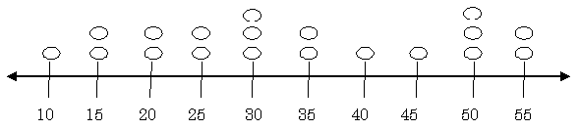
According to this graph, what is the mean, median, mode and range for the number of sit-ups for these 19 people?

4. Some students collected data on the number of shoes each student has in their closet. What would be an appropriate scale to use to create a histogram for the number of shoes in each students closet? The number of shoes ranges from 0 to 35.

5. The science test grades are posted. The class did very well. All students taking the test scored over 70. Unfortunately, 6 students were absent for the test and the computer listed their scores as 0 until the test is taken. Assuming that no score repeated more times than the 0’s, what measure of central tendency would most likely give the best representation of this data?

6. The table below shows the test scores of students in a math course.
Math Test Scores
Score | 50 - 59 | 60 - 69 | 70 - 79 | 80 - 89 | 90 - 100
Number of Students | 3 | 8 | 16 | 24 | 27
Make a histogram that correctly represents the data in the table above.

7. The box plot below represents the number of slushies bought over a semester by a group of freshmen.

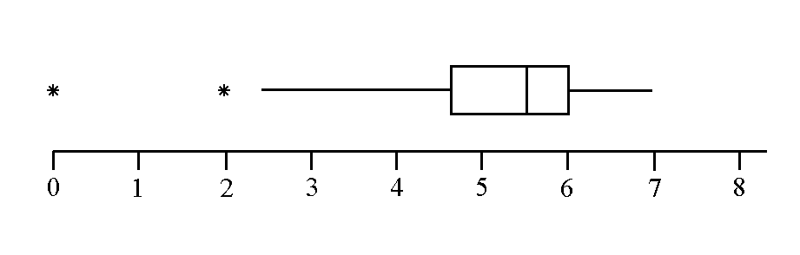
Based on the boxplot, give the five number summary as well as interpretations for each of the quartiles as well as the box.

Arithetic Practice Questions
1. Find the 21st term of the arithmetic sequence:
18, 23, 28, 33…..
2. Determine whether the sequence appears to be an arithmetic sequence. If so, find the common difference, write the explicit formula, and the next three terms in the sequence.
-5, -11, -17, -23, -29

3. The sequence below shows the number of trees a nursery plants each year.
2, 8, 32, 128, ...

Which formula could be used to determine the number of trees the nursery will plant next year, NEXT, if the number of trees planted this year, NOW, is known?

4. The sequence below shows the total number of days Francisco had used his gym membership at the end of weeks 1, 2, 3, and 4.
4, 9, 14, 19, ...
Assuming the pattern continued, which function could be used to find the total number of days Francisco had used his gym membership at the end of week n?

Find the next 3 terms using the following Next/ Now Statements:
5. Next = Now – 6 3, ____, ____, ____
6. Next = 3*Now + 2 -4, ____, ____, ____
7. Next = - ½ * Now + 5 -20, ____, ____, ___

