Unit 2: Translations Name:
Handout 1
THINK ABOUT IT!!!!!
Use the image of the humanoid (stick figure) above to answer the following questions.
- How has the humanoid moved from quadrant II to quadrant III?

- How has the humanoid moved from quadrant I to quadrant II?

- How has the humanoid changed from quadrant II to quadrant IV?

Investigation 1:
In this lesson, you will learn how coordinates can be used to transform shapes. You will investigate coordinate representations of rigid transformations that provide a way to reposition figures in a plane without changing the shape or size of the figures. You will also investigate coordinate representations of similarity transformations that can be used to resize figures while maintaining their shapes.
Question to think about: How can coordinates be used to describe a sliding motion or translation?

Translations: A translation, or sliding motion, is determined by distance and direction. By carefully looking at a simple shape and its translated image, you can discover patterns relating the coordinates of its shape and coordinates of the image.
Problem 1: In the picture below, a flag ABCDE and its translated image A’B’C’D’E’ are shown.
- Describe the translation as precisely as you can.

- Explain how the translated image of the flag could be produced using only the points A, B, C, D, and E.

- Under this translation, what would the image of the following points be?
  - (0, 0)?

  - (1, -5)?

  - (-5, -4)?

  - (a, b)?

- Write a rule you can use to obtain the image of any point (x, y) in the coordinate plane under this translation. State your rule in words and symbolic form $\left(x, y\right)→( , )$.
Problem 2: In the picture below, a flag and its translated image under two other translations are shown.
- Describe the vertical translation as precisely as you can. Also describe the oblique translation.

- Under the vertical translation, what would the image of the following points be?
  - (0, 0)?

  - (2, 5)?

  - (4.1, -2)?

  - (a, b)?

- Write a rule you can use to obtain the image of any point (x, y) in the coordinate plane under the vertical translation. State your rule in words and symbolic form $\left(x, y\right)→( , )$.

- Under the oblique translation, what would the image of the following points be?
  - (0, 0)?

  - (2, 5)?

  - (4.1, -2)?

  - (a, b)?

- Write a rule you can use to obtain the image of any point (x, y) in the coordinate plane under the oblique translation. State your rule in words and symbolic form $\left(x, y\right)→( , )$.

Problem 3: Compare the transformation rules you developed in parts d of problem 1 and parts c and e of problem 2. Write a general rule that tells how to take any point (x, y) and find its translated image if the preimage is moved horizontally h units and vertically k units.

Unit 2: Rotations Name:
Handout 2
Investigate!!!!
Rotations about the origin have similar coordinate models. A rotation, or turning motion, is determined by a point called the center of rotation and a directed angle of rotation. A flag ABCDE and its images under counterclockwise rotations of 90°, 180°, and 270° about the origin are shown below.
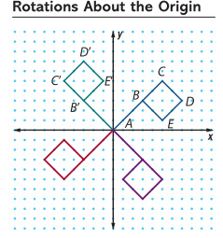
Problem 1:
Consider flag ABCDE above and its image under a 90° counterclockwise rotation about the origin.
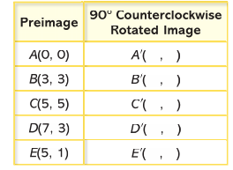
- On a copy of the table below, record the coordinates of the images of the five points on the flag under a 90° counterclockwise rotation about the origin.

Is there a pattern that you see between the original image and the 90° counterclockwise rotation about the origin? Be sure to explain using only the rotated images of points A, B, C, D, and E.

- Use any patterns you see between preimage and image points in your completed table in part a to help plot the points (-2, -5), (-4, 1), (5, -3), and their images under a 90° counterclockwise rotation about the origin on a new coordinate grid. Be sure to label each pre-image point and image point.
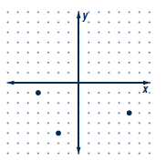
- Write a rule relating the coordinates of any preimage point (x,y) and its image point under a 90° counterclockwise rotation about the origin. State your rule in words and in symbolic form.
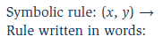

- According to your rule, what is the image of (0,0)? Why does this image make sense?

Problem 2:
As you probably expect, counterclockwise rotations of 180° and 270° about the origin also have predictable coordinate patterns. Use the graphs of flag ABCDE from the previous problems to explore these patterns (the graph below).
- Investigate patterns in the coordinates of the preimage and image pairs when points are rotated 180° about the origin.
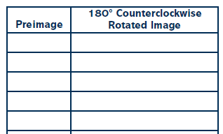
Is there a pattern that you see between the original image and the 180° counterclockwise rotation about the origin?

- Write a rule relating the coordinates of any preimage point (x,y) and its image point under a 180° rotation about the origin. State your rule in words and in symbols.
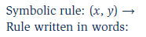

- Similarly, search for patterns in the coordinates of the preimage and image pairs when points are rotated 270° counterclockwise about the origin.
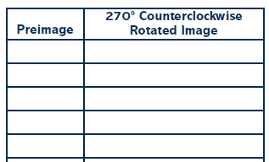
Is there a pattern that you see between the original image and the 270° counterclockwise rotation about the origin?

- Write a rule relating the coordinates of any preimage point (x,y) and its image point under a 270° counterclockwise rotation about the origin. State your rule in words and in symbols.
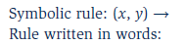

Problem 3:
- Take a look at the rotations in Problems 1 and 2. What type of rotation would a 90° Clockwise rotation be identical to?

- Write a rule relating the coordinates of any preimage point (x,y) and its image point under a 90° clockwise rotation about the origin. State your rule in words and in symbols.

- What type of rotation would a 180° Clockwise rotation be identical to?

- Write a rule relating the coordinates of any preimage point (x,y) and its image point under a 180° clockwise rotation about the origin. State your rule in words and in symbols.

- What type of rotation would a 270° Clockwise rotation be identical to?

- Write a rule relating the coordinates of any preimage point (x,y) and its image point under a 270° clockwise rotation about the origin. State your rule in words and in symbols.

Unit 2:Coord Transformations-Reflections Name:
Handout 3
Investigate!!!
Line reflections can also be expressed using coordinates. A line reflection is determined by a “mirror line” (or line of relfection) that is the perpendicular bisector of the segment connecting a point and its reflected image. A point on the line of reflection is its own image. In the following problems, you will build coordinate models for reflections across vertical and horizontal lines, as well as across the lines y = x and y = -x.
Problem 1:
A flag ABCDE and its reflected image across the y-axis are shown bellow.
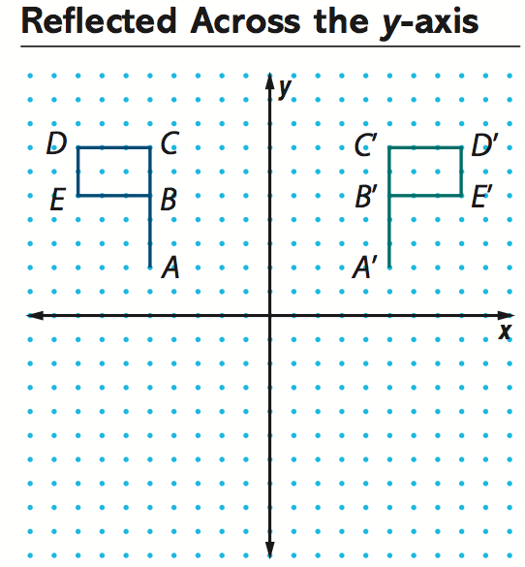
- Investigate patterns in the coordinates of preimage and image pairs when points are reflected across the y-axis. Explain any patterns you find.

- Write a rule which tells how to take any point (x,y) and find its reflected image across the y-axis. State your rule in words and in symbols.

Problem 2:
The table below shows coordinates of six preimage points and coordinates (a, b) of a general point. Plot each of the six points and its reflected image across the x-axis.
- Record the coordinates of the image points in a table like the one below. 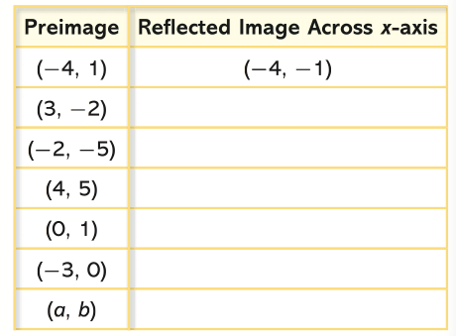

- What pattern relating coordinates of preimage points to image points do you observe? Use the pattern to give the coordinates of the image of (a, b).

- Write a rule that tells how to take any point (x, y) and find its reflected image across the x-axis. State your rule in words and symbolically.

Problem 3:
Draw the graph of y = x. Plot each preimage point in the table below and its reflected image across that line. Connect each preimage/image pair with a dashed segment.
a. Record the coordinates of the image points in a copy of the table below.
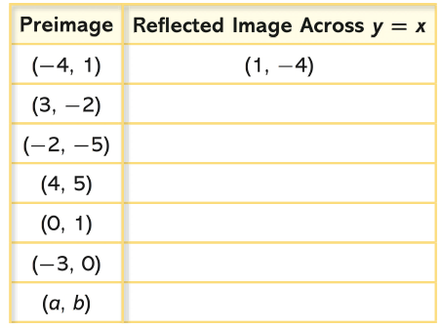
- Describe a pattern relating coordinates of preimage points to image points.

- Write a rule relating the coordinates of any preimage point (x, y) to its reflected image across the line
y = x. State your rule in words and in symbols.

Problem 4:
Next, investigate patterns in the coordinates of the preimage and image pairs when points are reflected across the line y = -x.
- Draw the graph of y = -x with the pre-image points below.
- Reflect the preimages across the line y = -x and plot the size image points.

- Describe a pattern relating coordinates of preimage points to coordinates of image points.

- Write a rule relating the coordinates of any preimag point (x, y) and its reflected image across the line
y = -x. State your rule in words and in symbols.

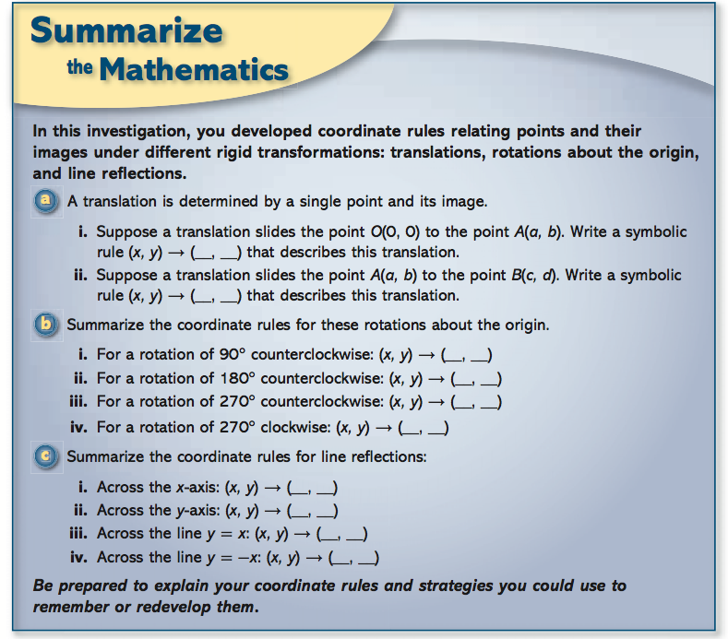

Unit 2:Coord Transformations-Dilations Name:
Handout 4
In the previous investigation, you found patterns in the coordinates of preimage/image pairs for transformations with which you were familiar. As you complete the problems in this investigation, look for an answer to this question:
How can coordinates be used to rescale or resize a shape?
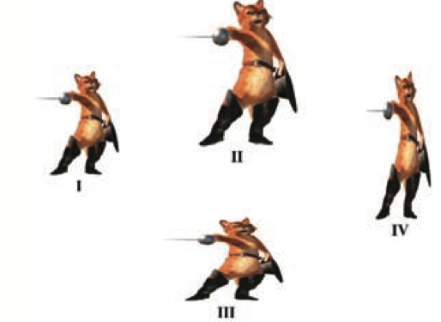
Problem 1:
Consider first the transformation defined by the following rule:
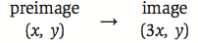
This rule is read “the x-coordinate of the image is 3 times the x-coordinate of the preimage; the y-coordinate of the image is the same as the y-coordinate of the preimage”

- Which of the figures II, III, or IV (above) appears to be the image of figure I under this transformation? Explain your reasoning.

- On a coordinate grid, plot the points X(1, 1), Y(5, 1), and Z(5, 5). Draw XYZ and its image under this transformation.
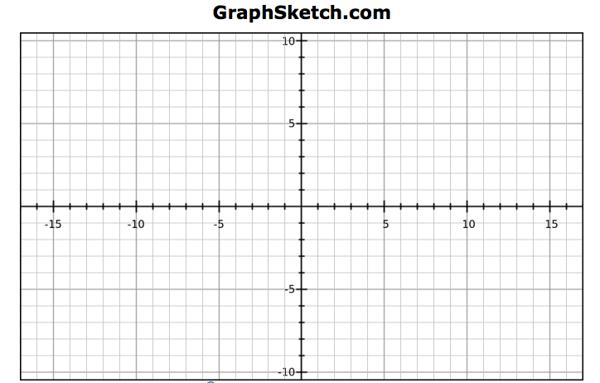
- Examine your preimage and image shapes. What characteristics of XYZ are also characteristics of its image? How do the shapes differ?

- How do you think the perimeter of XYZ will compare to the perimeter of its image? How do you think the area of XYZ will compare to the area of its image? Test your conjectures..

- Which of figures II, III, or IV (page 1) could be the image of figure I when transformed by the rule:
What clues did you use?

Your work on problem 1 has shown that even a simple transformation might not preserve all characteristics of the preimage shape. By modifying the transformation rule slightly, you can create a transformation which has many interesting and useful characteristics.

Problem 2:
A size transformation (or dilation) of magnitude 3 centered at the origin is defined by the following rule:
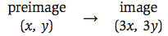
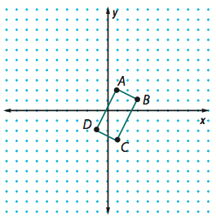
- On a copy of the diagram shown above, draw the image of quadrilateral ABCD under this size transformation. Label image vertices A’, B’, C’, and D’.

- Examine your preimage and image shapes. How are the perimage and image shapes similar? How are they different?

Problem 3:
Making visual comparisons, as you did in problem 2, is useful; but such comparisons should be made with some skepticism. You should always seek additional evidence to support or refute your visual conjectures. This is where coordinate representations and formulas for distance and slope can be very helpful. Use these ideas to examine more carefully quadrilateral ABCD and its image quadrilateral A’B’C’D’ that you drew in problem 2.
- Compare the length of AB with the length of A’B’. Does the same relation hold for other preimage/image pairs of the segments? Explain.

- How does AB appear to be related to AD? Does the same relationship hold for their images? Give evidence to support your claim.

- How do the perimeters of quadrilateral ABCD and quadrilateral A’ B’, C’, D’ compare?

- How does BC appear to be related to AD? Is this relationship true for their images? Justify your conclusion.
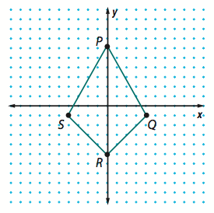
Problem 4:
Next, consider a size transformation with magnitude 0.5 and center at the origin.
- Write a rule for this size transformation.

- On a copy of the diagram shown here, plot and label the image of quadrilateral PQRS under this size transformation. How do you think quadrilateral PQRS and its image are related in terms of shape and size?

- Compare segment lengths in the image with corresponding lengths in quadrilateral PQRS. How does the magnitude 0.5 affect the relation between lengths and perimeters?

- Find the area of the image quadrilateral. Compare it to the area of quadrilateral PQRS. How does the magnitude 0.5 affect the relation between areas.

Unit 2: Transformations Name:
Homework Packet 1
Due :
Homework 1:
- In example 1 from above A(-3, 4) was translated by (2, -5). The image A’ is represented by (-3 + 2, 4 + (-5)) = (-1, -1). Write the translation rule for this example.

- Write the translation 4 units to the left and up 2 units as a rule. Then, apply this rule to the points J(0, -3) and T(4, 8).

- Apply the rule (x’, y’) (x, y-3) to the point W (4, 5).

- Apply the rule (x’, y’) (x+4, y-1) to the figure DEFG in the graph. After applying the rule to the graph, write the coordinates for the image.
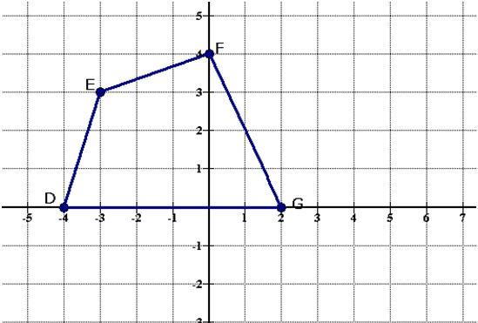

Homework 2:

- Perform the indicated transformations
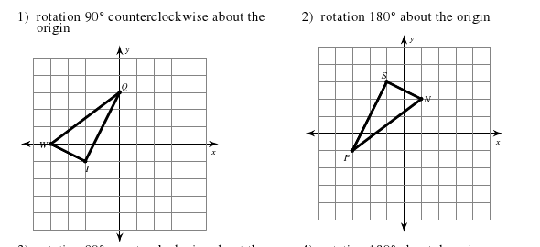

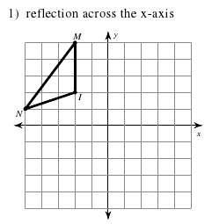
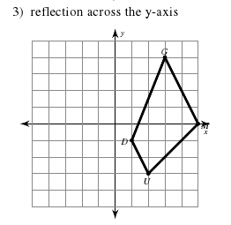

- The image of point W is W’ (-4, 0) after a 90º counterclockwise rotation about the origin. What are the coordinates of W?

- What kind of transformation is the same as a 90º rotation clockwise?

- What kind of transformation is the same as a 90º rotation counterclockwise?

Homework 3:

- What is the image of point B(3, 5) after each reflection. Begin with this point for each part.

- Across the y-axis? b) Across the x-axis?

- The graph below shows the pre-image of ABC and the image $A^{'}B^{'}C^{'}.$

- What reflection took place here?
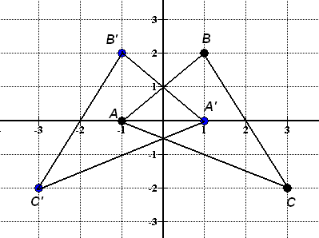

- The graph below show the pre-image RST and the image $R^{'}S^{'}T.$ What reflection took place?
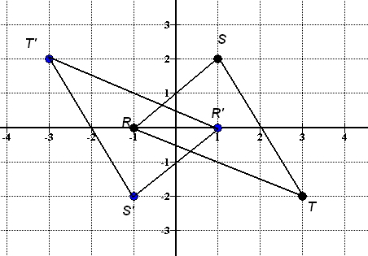

  - The point (4, 3) has been reflected across the x-axis. What is the image of this point?

  - The point (-3, -8) has been reflected across the y-axis. What is the image of this point?

  - The point (-a, -b) has been reflected across the line y = - x. What is the image of this point?

  - ∆XYZ is defined by its vertices X(1,3), Y(-3,5), and Z(0, -5). ∆XYZ is reflected in the y-axis. What are the coordinates of its image X’Y’Z’?

  - Write a rule in symbolic form to describe the transformation.

Homework 4:

The rule (x, y)(2x, 2y) is a dilation by what factor?

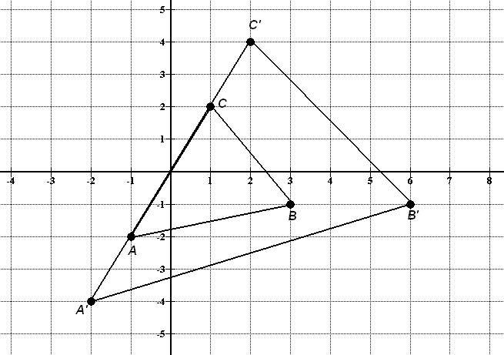
- What is the dilation factor applied to the pre-image in the graph that gives the resulting image $A^{'}B^{'}C^{'}?$

- Find the scale factor of the dilation, with respect to the origin, for the mapping of (1, -3)→ (4, -12)?

- What is the scale factor of the dilation if point W (6, 4) becomes W’ (24, 16)?
- Under a dilation of scale factor 5/2 with the center at the origin, if N (4, 5), what will be the coordinates of the point N’?

- A picture is to be placed in a brochure, and the designer wants it positioned in a 2” x 3” frame. If the original picture is a 6” x 9”, what transformation should be applied to the picture so it will fit in the frame? Be sure to include the rule for the specific transformation.
Homework 5:

- For the graph to the right, find the coordinates of the image for the following transformations. For each part, begin with points P, Q, and R.
a) an enlargement of 2

b) rotation of 90º clockwise

c) reflection over y= -x

d) translation 6 units down and 3 units right

e) reflection across the origin

- Use the points $\left(2, 5\right) \left(-1, 4\right) \left(-10, -3\right)$ to perform the following transformations. For each part start with the original points.
  - Translate 5 units left and 7 units up, then dilate the image by a scale factor of 2.

  - Reflect the pre-image over the origin then rotate it 90º clockwise.

  - Reflect the pre-image over the x-axis, then translate 3 units right, 8 units down.

Transformation Mix Group Mini Project
With your group, complete each problem. You will be transforming a figure multiple times in one problem. When you are done with step 5 in each problem, graph the final image on the graph paper supplied. USE THE RULES GIVEN TO YOU IN YOUR NOTES!!!!!
Problem 1:
- Sketch the following figure: C (2, 5), A (-1, -5), T (0, 4)
- Rotate the figure 270º CW, to the figure made in step 1
- Apply the following rule (x’, y’)→ (x-2, y+1) to the figure made in step 2
- Apply the dilation factor of 2, to the figure made in step 3
- Reflect the figure over the line y= -x, to the figure made in step 4.

Problem 2:
- Sketch the following figure: M(-3, 6), A(4, 0), P(2, -5)
- Apply the following rule (x’, y’)→ (x-3, y-2) , to the figure made in step 1
- Rotate the figure 270º CCW, to the figure made in step 2
- Apply the dilation factor of 2, to the figure made in step 3
- Reflect the figure over the y-axis , to the figure made in step 4

Problem 3:
- Sketch the following figure: F(2, 4), R(8, -6), O(-10, 2), G(-6, -6)
- Apply the dilation factor of ½, , to the figure made in step 1
- Apply the following rule (x’, y’)→ (x+4, y+5) , to the figure made in step 2
- Rotate the figure 180º CCW, to the figure made in step 3
- Reflect the figure over the origin, to the figure made in step 4

Problem 4:
- Sketch the following figure: Z(4,0), E(-5, 2), S(2, 6), T(-1, 5)
- Reflect the figure over the x-axis, to the figure made in step 1
- Rotate the figure 90º CW, to the figure made in step 2
- Apply the dilation factor of 2, to the figure made in step 3
- Apply the following rule (x’, y’)→ (x, y-3) , to the figure made in step 4
Name: Date:
Unit 1- Transformations Mix

Perform the indicated transformations.
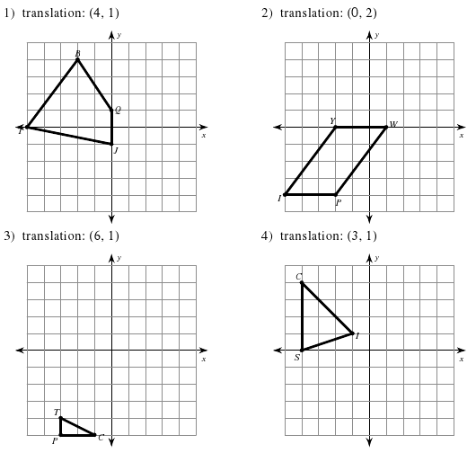

A dilation by a scale factor of 1/2 was applied to QRS. The image is as follows: Q’(-8,4), R’(8,0), and S’(0,-4). Find the coordinates of Q, R, and S.

A translation of (-3, 7) was applied to the figure DMNR. What are the coordinates of the translation if D(0,9), M(3, 4), N(-1, -1), R(-6, 7)?

If Z ‘ = (-8, 4) after the translation of (x’, y’) -> (x-3, y+9), what are the coordinates of Z?

What transformation is shown in the graph below?
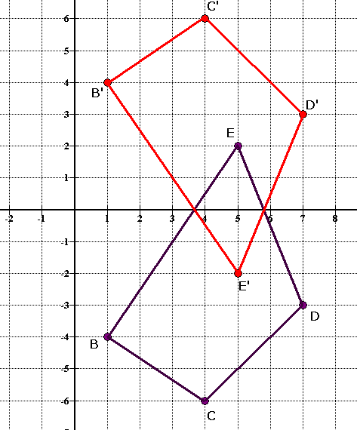

What is the transformation shown below?

For the graph to the right, find the coordinates of the image for the following transformations.
a) an enlargement of 2

b) reflection over y= -x

c) translation 6 units down and 3 units right

d) reflection across the origin

