Solve the following equations.
1. 2x - 1 = 7 2. 2x² – 1 = 7

What are the differences and similarities in solving the first equation to the equation 2x² – 1 = 7?

Complete each table and graph both equations on the grid below.
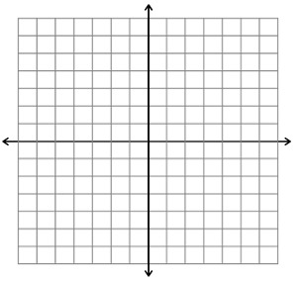

Use the following terms to label the graph below: parabola, vertex, zeros and the axis of symmetry.
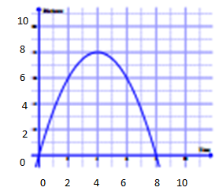
What are the zeros or x-intercepts in the grid above?

What is the y-value of the x – intercepts?

What will a quadratic equation be set equal to in order to find the x-intercepts?

Factor and solve for the variable for the following problem. REMEMBER!!!!! Set the equation equal to zero, then set your factors equal to zero!

