Module 3 Test Review
- What key features do you look for in a function?

- What is a function? Provide a verbal description as well as examples and non-examples of functions.

- Match the story to the graph:
- 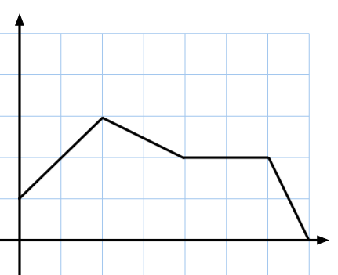  - 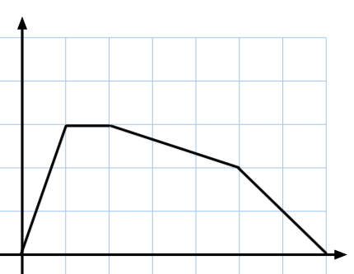  - 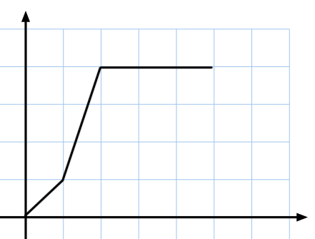  - 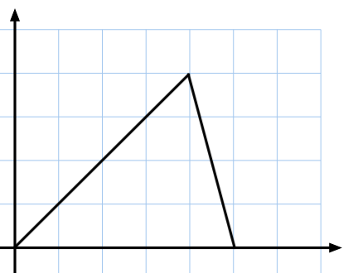 | A. Larry leaves from home in his dad’s car going to school. He stays there for a bit and then heads home on foot. Then he gets to his friends house and rides their bike the rest of the way home.  B. Bob rides his bike to his mom’s work for fun. Then when he gets there, he puts the bike in her car and rides home with her from work.  C. Marcos starts at his neighbor’s house and rides with them to the elementary school. Then he walks to the high school which is closer to his house. Then he stays at school for the day and then rides the bus back home.  D. Buttercup walks to the bus stop and then rides the bus to school and stays for the day.

- Below you are given some key features of a function. Based on these given features, sketch a graph of what the function could possibly look like.
- The function has three intervals on which it is increasing
- The function has two intervals on which it is decreasing
- The domain of the function is [−5, 7)
- The function has a minimum value of 0
- The function has a maximum value of 2.

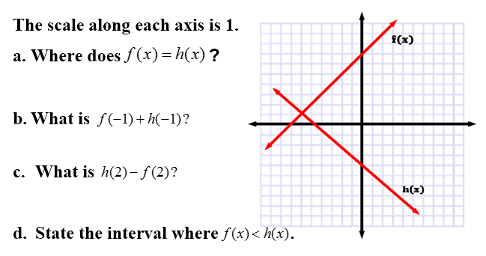

6. Two functions are graphed. Graph a new function on the given graph by adding the two functions together, g(x)=f(x)+h(x).
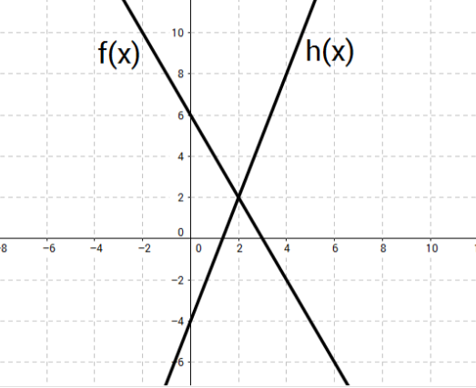

7. A scuba diver is exploring a coral reef. This graph models their exploration along the reef. What is the range of the depth of the coral reef?
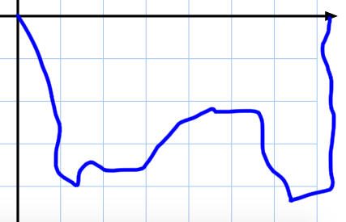

- [0, 7.2]
- [0, -4.3]
- [7.2, 0]
- [-4.3, 0]

8. List the similarities and differences of the two graphs. (Consider attributes like continuous, discrete, increasing, decreasing, linear, exponential, domain and range.)

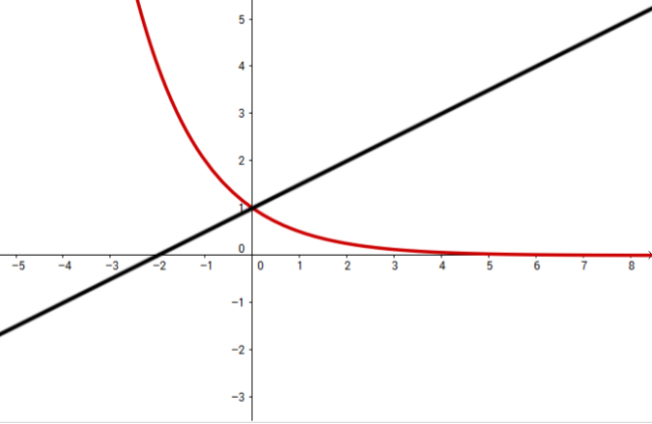
9. Given $f(x) = -x+ 3. when x≥0$
- What does x represent?

- What does f(x) represent?

- Graph the function.

- Describe key features of the graph (linear or exponential, x- and y- intercepts, domain, range, minimum, maximum)

10. Using interval notation, identify the domain, range and whether the function is increasing or decreasing.
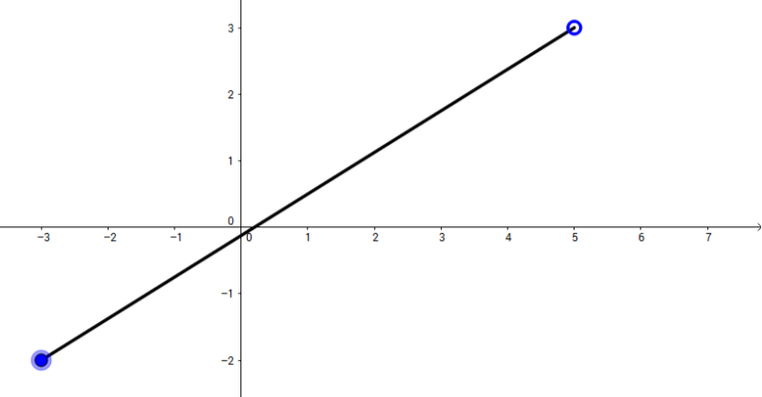

11. Given the graph of f(x), answer the following questions:
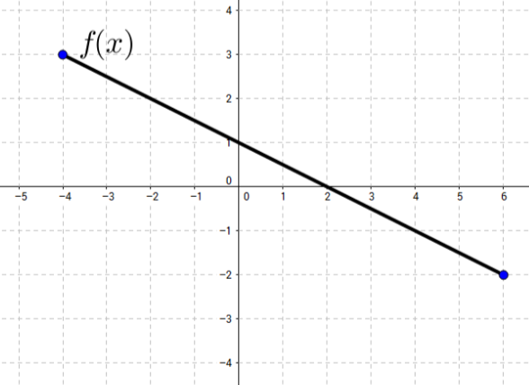

What is f(-2)? | What is f(0)? | What is f(4)?
For what value does f(x) = -2? | What is the x-intercept? | What is the y-intercept?
On what interval is f(x) < 0? | On what interval is f(x) > 0? | Is f(x) increasing or decreasing?
State the domain of f(x). | State the range of f(x). | Is f(x) continuous or discrete? Why?

