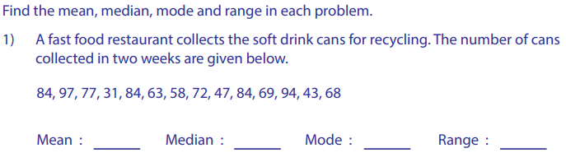

1st Quartile: _________ 3rd Quartile: _______ Interquartile Range :_______
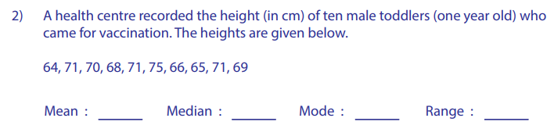
1st Quartile: _________ 3rd Quartile: _______ Interquartile Range :_______
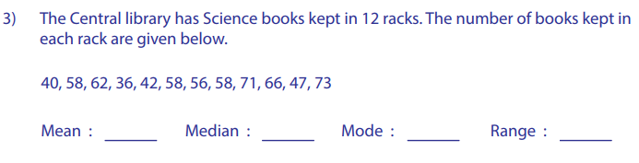
1st Quartile: _________ 3rd Quartile: _______ Interquartile Range :_______
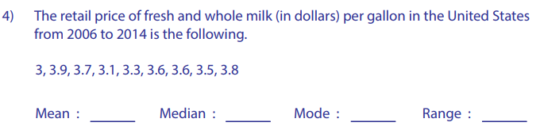
1st Quartile: _________ 3rd Quartile: _______ Interquartile Range :_______

