1. List the sample space for each of the following:
a) Tossing a coin:

b) Drawing a marble from a bag containing 2 red marbles, 4 blue marbles and 4 yellow marbles.

2. A bowl contains 12 slips of paper, each with a different name of a month. Find the theoretical probability that a slip selected at random from the bowl has a name of a month that starts with the letter J.

3. On a popular television game show, a contestant must choose one of the five envelopes. One envelop contains the grand prize, a car. Find the probability of not choosing the car.

4. In an interview of 70 students, 28 students took PE , 30 students took Biology and 12 took both PE and Biology. Make a Venn Diagram and answer the following questions.
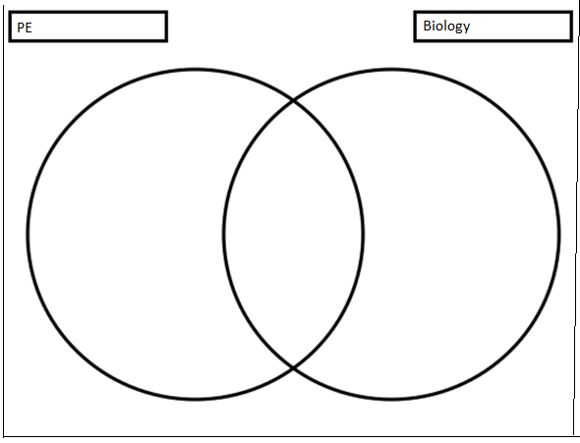
a) What is (PE $∪$ Biology)?
b) What is (PE $∩$ Biology)?
c) What is (PE $∪$ Biology)^{c}?
d) What is (PE $∩$ Biology)^{c}?

4. A card is drawn at random from a standard deck of cards. Find the probabilty that a card is a 4 or a queen?

5. Suppose a sandwich shop offers 3 types of bread, 5 types of cheese, 3 types of meat and 6 toppings. How many different sandwiches can be made?

6.For the first day of school, Pam has to choose what to wear from the following : 3 pants, 5 shirts, and 2 shoes. How many possible outfits does he have to choose from?

7. At Enloe High School, 25% of students have a part time job and 35% of students are on the honor roll. What is the probability that a student chosen at random has a part time job and is on the honor roll?

8. Two hundred and forty people were surveyed based on what they drive.
a) What is the probability that a person chosen at random will be a male ?

b) What is the probability that a person is driving a sports utility vehicle?

c) Suppose 2 people both randomly chose 1 student from the grade 12 class. Assume that it’s possible for them to choose the same student. What is the probability that the first person is a male and the second person is driving a sports utility vehicle?

9. Suppose a card is chosen at random from a deck of cards, not replaced, and then a second card is chosen. What is the probability that both cards are kings?

