1. Identify the vertex of the graph. Tell whether it is a minimum or maximum.
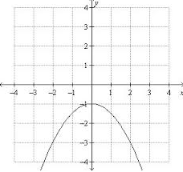
2. Circle the quadratic functions with the widest graph.
y = 1/2x² y = -4x² y = x²
3. If an object is dropped from a height of 144 feet, the function h(t) = -16t² + 144 gives the height of the object after t seconds. Graph the function.
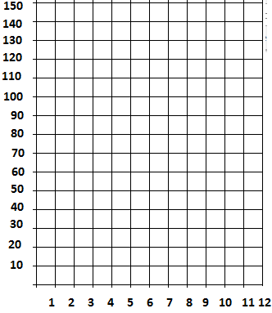
4. Find the axis of symmetry and the coordinates of the vertex of the graph of y = -3x² + 12x – 20.

5. Graph f(x) = x² + 8x + 9. Label the axis of symmetry and vertex.
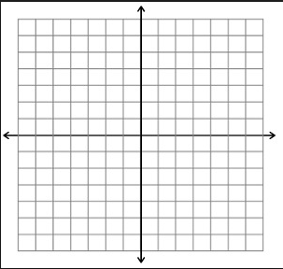
6. Suppose you have 52 feet of fencing to enclose a rectangular dog pen. The function A=26x-x², where x = width, gives you the area of the dog pen in square feet. What width gives you the maximum area? What is the maximum area? Round to the nearest tenth as necessary.

7. A ball is thrown into the air with an upward velocity of 80 ft/s. its height h in feet after t secods is given by the function h = 80t -16t². In how many seconds does the ball reachits maximum height? Round to the nearest hundredth if necessary. What is the ball’s maximum height?

8. Solve x²+ 1 = 5 by graphing the related function.
Solve the following equations using square roots.
9. x² - 20 = 5

10. x² - 19 = -100

11. Solve ( x + 9) (5x -3) = 0 using the Zero Product Property.

Solve the following equations by factoring.
12. x² – 10x + 9 = 0

13. 3x² – 2x + 5 = 0

14. x²- 8x = 0

15. The expression ax²-bx = 0 ___________has the solution x = 0.

Solve the following equations by completing the square.
16. x² + 2x = 35

17. x² – 6x = -91
Use the Quadratic Formula to solve the following equations.
18. 5x²+ 19x +12 = 0

19. 3x² + 10 = 4x

20. A rocket is launched from atop a 105 foot cliff with an initial velocity of 156 ft/s. Substitute the values into the vertical motion formula h=-16t²+ vt + c. Let h = 0. Use the quadratic formula find out how long the rocket will take to hit the ground after it is launched. Round to the nearest tenth of a second.

21. For which discriminant is the graph possible?
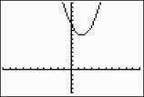

b² - 4ac = -12 b² - 4ac = 0 b² - 4ac = 2

Find the number of real solutions.
22. x² – 10 = 0

23. Solve the following system by graphing. (show the work for the solutions;vertex and x-intercepts)
y = x² – 4x – 2
y = x – 2
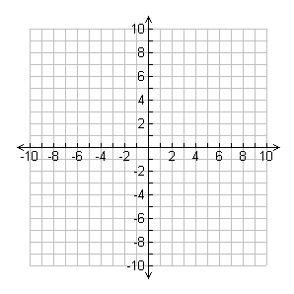
Graph the system of quadratic inequalities. (Show work for the vertex and x-intercepts)
24. y ≥ x²
y ≤ x² + 3

