1. y = x² – 10x + 24
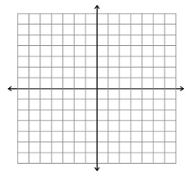
Max or min?___________
Vertex_________
Axis of symmetry___________
Roots________

2. y = x² – 10x - 24
Max or min?___________
Vertex_________
Axis of symmetry___________
Roots________

3. y = x² – 15x + 56
Max or min?___________
Vertex_________
Axis of symmetry___________
Roots________
4. y = x² – 13x + 12
Max or min?___________
Vertex_________
Axis of symmetry___________
Roots________
5. y = x² + 23x + 22
Max or min?___________
Vertex_________
Axis of symmetry___________
Roots________
6. y = x² – 19x + 90
Max or min?___________
Vertex_________
Axis of symmetry___________
Roots________
7. Suppose that the equation V = 20.8x² – 458.3x + 3,500 represents the value of a car from 1964 to 2002. What year did the car have the least value? (x = 0 in 1964)

