NOTES: Pythagorean Theorem

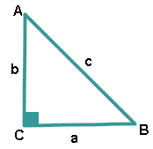 Deals with the relationship between the side lengths in a

RIGHT TRIANGLE

Sides A and B are both called ___ _________

Side C is called the ____ _________

This side is always the ____ ______

and it is opposite from the right angle.

The relationship that is true for every right triangle, as stated in the

Pythagorean Theorem, is:

Examples: Calculating the missing sides of a right triangle.





Examples: Determine whether a triangle with the given side lengths is a right triangle.

**Pythagorean Triple: Pythagorean triple consists of three positive integers *a*, *b*, and *c*, such that *a*2 + *b*2 = *c*2.

a) 7 in, 24 in, 25 in b) 6 m, 7 m, m c) 8 cm, 10 cm, 12 cm

