# Pythagorean Theorem

In any ***RIGHT*** triangle, the sum of the squares of the lengths of the two **legs** is equal to the square of the length of the **hypotenuse**.

a

b

c

### Legs

### Hypotenuse

**a2 + b2 = c2**

**Example 1**: Find the length of the **hypotenuse**.

3

4

x

**Example 2**: Find the length of the **hypotenuse**.

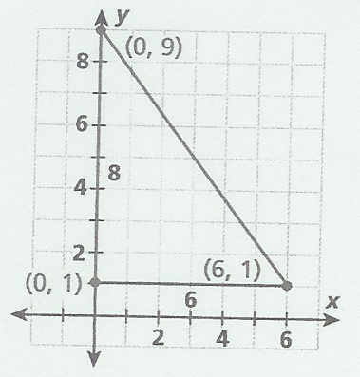

**Example 3: Find the missing side of the triangle.**

x

5

13

**Example 4:** Find the missing side in simplest radical form.

x

14cm

10cm

**Example 5**: Find the unknown **leg** in the right triangle, in simplest radical form.

x

3

13

**Practice**: Find the length of the missing side. Keep answer in simplest radical form.

7

8

x

x

15in

20in

x

25ft

15ft

1. 2. 3.

Name\_\_\_\_\_\_\_\_\_\_\_\_\_\_\_\_\_\_\_\_\_\_\_\_\_\_\_\_\_\_\_ Date\_\_\_\_\_\_\_\_\_\_\_\_\_\_\_\_\_\_

HW #8

1. Find the length of the hypotenuse of this right triangle. Round to the *nearest*

*tenth*.

x

5

2

2. Find the length of the hypotenuse of this right triangle.

15m

8m

x

3. Solve for the unknown side in this right triangle.

5

x

13

4. Solve for the unknown side in this right triangle. Put your answer in simplest radical form.

x

12in

6in

5. Solve for the unknown side in this right triangle. Round to the *nearest*

*thousandth*.

10

x

14

1. Solve for the unknown side in this right triangle. Put your answer in simplest radical

form.

x

9

8

**Review**:

1. Solve for x: 18x – (4x – 10) = 24

2. Check your answer for Review #1.

3. After a 5-inch-by-7-inch photograph is enlarged, its shorter side measures

20 inches. Find the length in inches of its longer side. [Draw Pictures!!!]

## 

## 

## Pythagorean Theorem Word Problems

**Warm**

Solve for x.

20ft

x

10ft

1. 2.

6cm

8cm

x

**Word Problems with the Pythagorean Theorem:**



Steps:

* Read the problem.
* Identify key elements.
* Draw a picture.
* Solve for the missing side.
* Label your answer!

1. A ramp was constructed to load a truck.  If the ramp is 9 feet long and the horizontal distance from the bottom of the ramp to the truck is 7 feet, what is the vertical height of the ramp?

2. There is a 13-foot ladder leaning against the side of a building. The ladder reaches up the building 12 feet. How far is the bottom of the ladder from the bottom of the building?

3. Find the diagonal of a square whose sides are 5cm long.

4. Ms. Green tells you that a right triangle has a hypotenuse of 13 and a leg of 5.  She asks you to find the other leg of the triangle.  What is your answer?

5. A suitcase measures 24 inches long and 18 inches high.  What is the diagonal length of the suitcase to the *nearest tenth* of a **foot**? [**Note**: Once you find your answers in inches, you must convert it to feet!]

bs00453_

# Name: \_\_\_\_\_\_\_\_\_\_\_\_\_\_\_\_\_\_\_\_\_\_\_\_\_\_\_\_\_\_\_ Date: \_\_\_\_\_\_\_\_\_\_\_\_\_\_\_

HW #9

1. A wall is supported by a brace 10 feet long, as shown in the diagram below. If one end of the brace is placed 6 feet from the base of the wall, how many feet up the wall does the brace reach?

10ft

6ft

2. The two legs of a right triangle are 9 and 7. Find the hypotenuse of the triangle. Draw a picture! Leave your answer in radical form.

3. How many feet from the base of a house must a 39-foot ladder be placed so that the top of the ladder will reach a point on the house 36 feet from the ground? Draw a picture!

**Review**

Find the **perimeter** of the triangle below. Show all work for final answer!

\*Hint: Need to find the missing side first.

50cm

30cm