Factoring Quadratics Name:

Handout 1

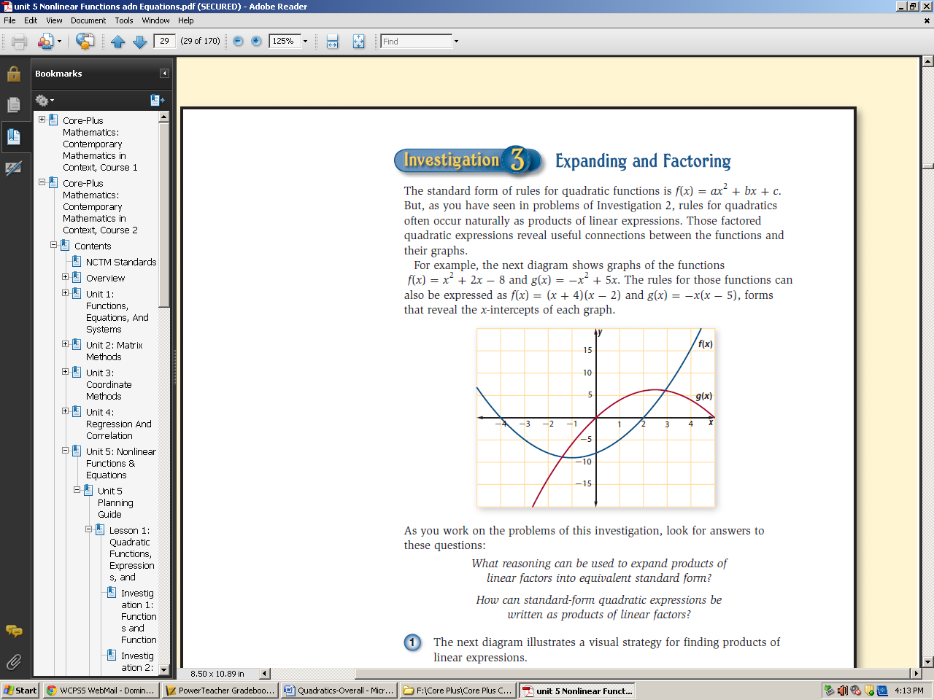Part I:

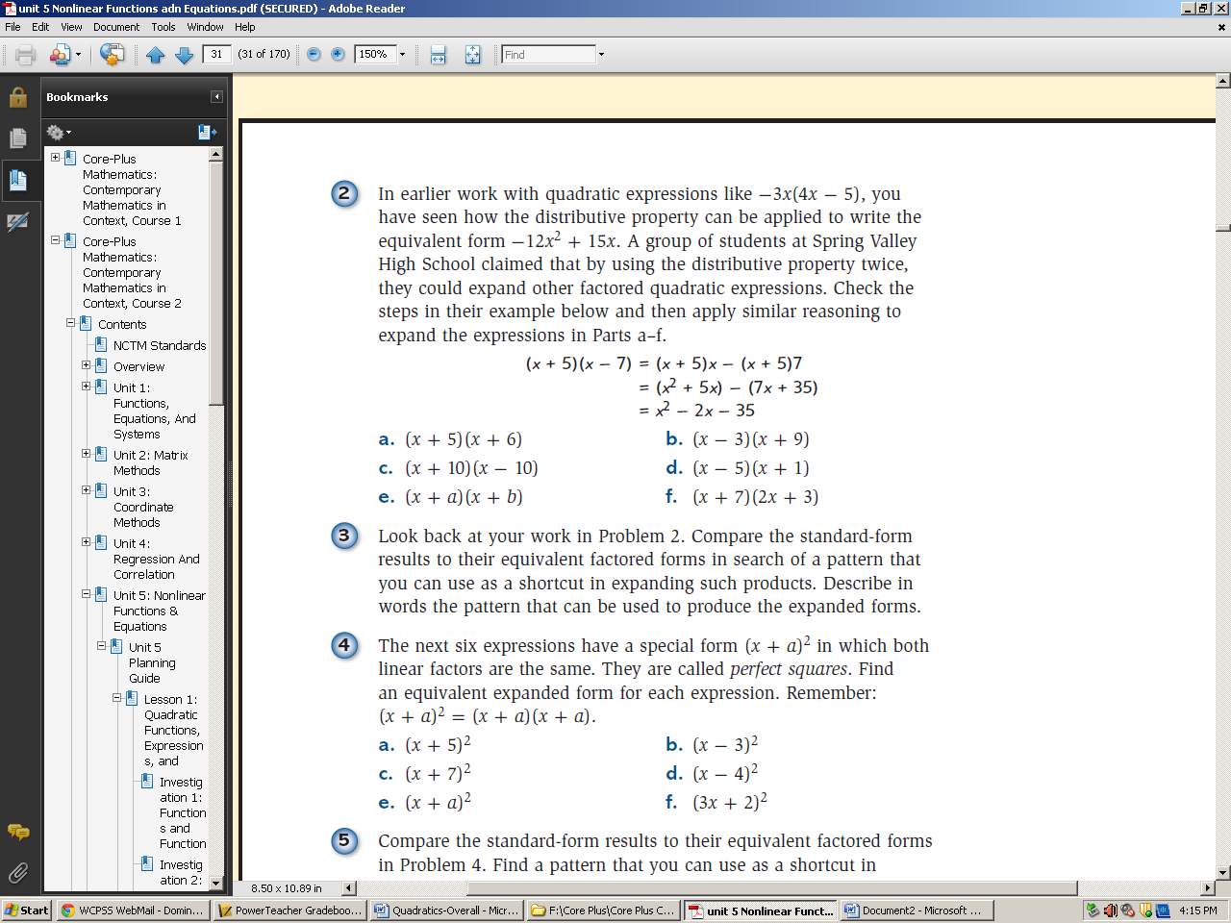

Part II:

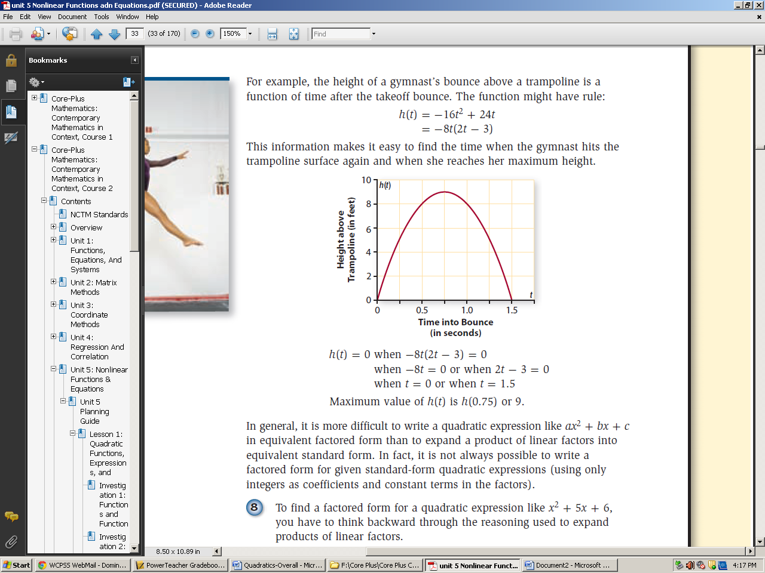Remember, zeros represent the x-intercepts on our graph.

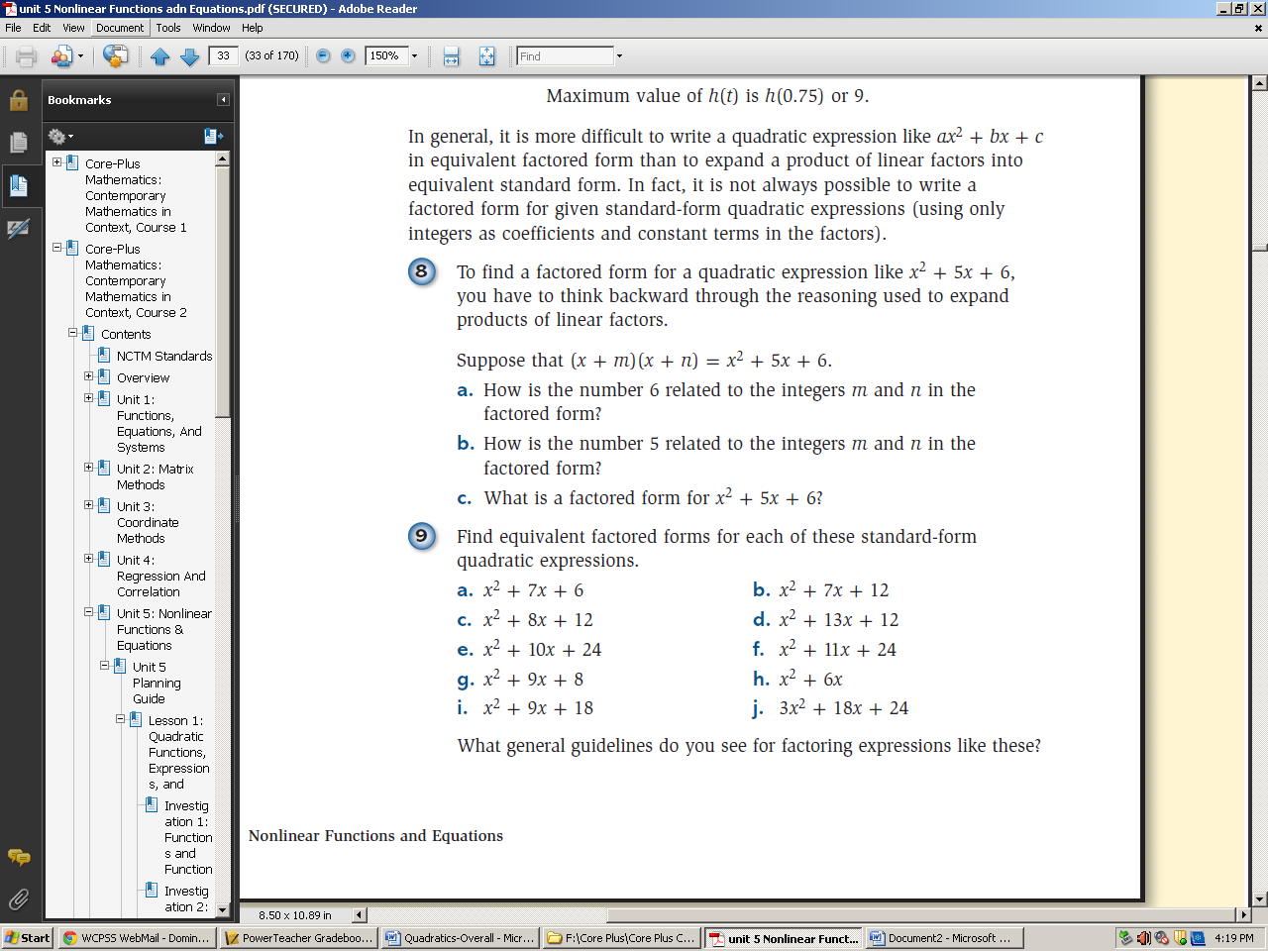Sooo……

Part III:

Fill in the following chart.

|  |  |  |  |  |
| --- | --- | --- | --- | --- |
| FACTORS | PRODUCT | a | b | c |
|  |  | 1 | 8 | 15 |
|  |  |  |  |  |
|  |  |  |  |  |

Answer the following questions given the chart you filled in above

1. Initially, what patterns do you see?
2. How is the value of “a” related to the factors you see in each problem?
3. How is the value of “b” related to the factors you see in each problem?
4. How is the value of “c” related to the factors you see in each problem?

Knowing this, fill out the values for a, b, and c in the following chart. Work backwards using your rules from the last part to find 2 binomial factors for each product. Put these in the first column.

|  |  |  |  |  |  |
| --- | --- | --- | --- | --- | --- |
| FACTORS | PRODUCT | a | b | c | Hint: List factors of “c” |
|  |  |  |  |  |  |
|  |  |  |  |  |  |
|  |  |  |  |  |  |
|  |  |  |  |  |  |
|  |  |  |  |  |  |
|  |  |  |  |  |  |

Part IV:

1.



Use the distributive property to multiply and then simplify the following binomials.

2.  3.  4. 

5. Where do you expect each of the above equations to “hit the ground”?

What if a isn’t 1…. Name:

Notes

**Solving Quadratic Equations using alternate methods……like slide and divide……**

Let’s say we are given a equation in standard form $ax^{2}+bx+c=0$ but this time $a≠1$. What do we do???????

**Example:** Solve $3x^{2}-5x=2$

$3x^{2}-5x-2=0$

$a= b= c=$

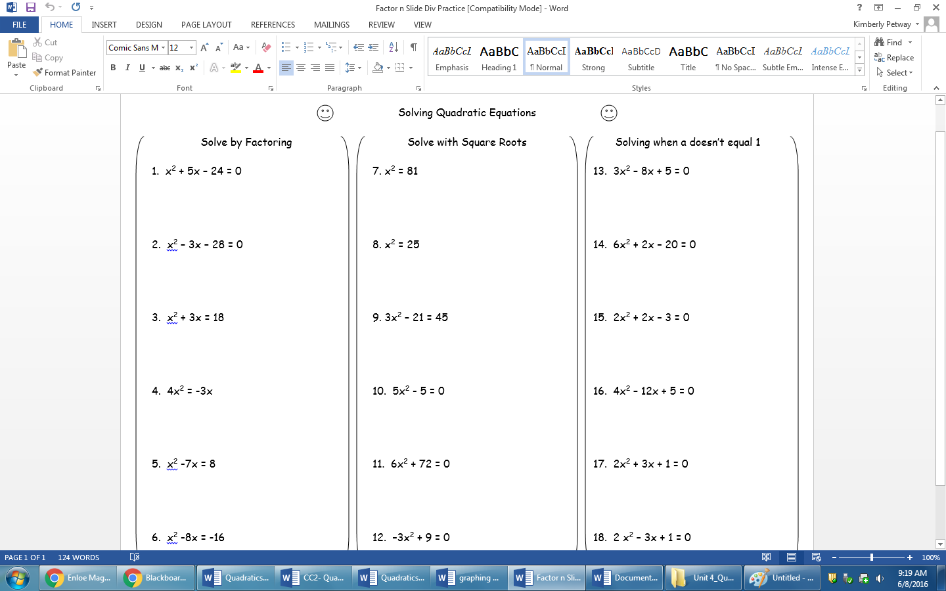

Quadratic Formula Name:

Notes Handout 2

**Solving Quadratic Equations using Quadratic Formula**

Given an equation in standard form, $y=ax^{2}+bx+c$, you can solve for x using the quadratic equation.

$$x=\frac{-b±\sqrt{b^{2}-4ac}}{2a}$$

**Example:** Solve $3x^{2}-5x=2$

$3x^{2}-5x-2=0$

$a= b= c=$

$x=$

$x=$

$x=$

$x=$

**Find the solution(s) to each equation.**

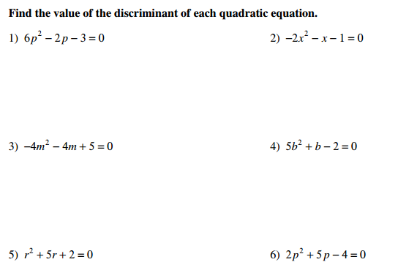

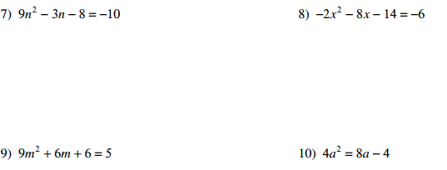

Quadratics- Discriminant Name:

Notes Handout 3

**Discriminant:**

The discriminant can help us determine the type and number of solutions the function has.

$Discriminant= b^{2}-4ac$**(comes from quadratic formula)**

|  |  |  |
| --- | --- | --- |
| **Value of Discriminant** | **Type & Number of Solutions** | **Examples of Graph** |
| $$b^{2}-4ac>0$$ | **Two Real Solutions** |  |
| $$b^{2}-4ac=0$$ | **One Real Solution** |  |
| $$b^{2}-4ac<0$$ | **no real solutions** |  |

**Example:**

Determine the number of solutions the function has.

$y=x^{2}+6x+8$

Find the value of the discriminant. Then find the number and type of solutions for each equation.



**Find the solution(s) to each equation.**



Name: Date:

CC2-Quadratic Formula-Discriminant Practice Quiz Honors

Solve the following using factoring, slide divide, or the quadratic formula.

1. 2.

3. 4.

5. 6.

For the following functions, determine how many real solutions exist.

7. 8.

9. 10.

Name: Date:

Quadratics Practice Test Honors

For the following, solve for x.

|  |  |
| --- | --- |
| $x^{2}-6x=40$ | $x^{2}+6x=16$ |
| $3x^{2}+7x=-3$ | ${3x}^{2}+5x-2=0$ |

Use quadratic formula to solve for x.

|  |  |
| --- | --- |
| $x^{2}+9=9x$ | ${2x}^{2}-3x-12=0$ |

Determine how many solutions each function will have.

|  |  |
| --- | --- |
| ${f\left(x\right)=x}^{2}+4x-9$ | ${f\left(x\right)=2x}^{2}+8x-3x$ |

1. Jason jumped off a cliff into the ocean in Acapulco while vacationing. His height as a function of time could be modeled by the function $h\left(t\right)=-16t^{2}+12t+360$. Answer the following questions.
2. What time would you expect Jason to land in the ocean?
3. What is the axis of symmetry for Jason’s jump?
4. How many seconds did it take for Jason to reach the highest point of his jump?
5. What is the highest point of his jump?

EQ: How do I graph quadratic inequalities? NAME______________________

Steps to graphing quadratic inequalities:

1. Determine if you will use a solid or a dashed line to graph.
2. Find the vertex using: $x=-\frac{b}{2a}$, then plug this value in solve to for y.
3. Find the x-intercepts using:
   1. Factoring, or
   2. Quadratic formula
4. Plot vertex and x-intercepts; ***If there are no x-intercepts, you will need to pick 2 points around the vertex (one on the left and one on the right).
5. Shade appropriate region on graph
6. Check graph on calculator

Try it out!!!!

1. *y* ≤ *x*2 + 3*x* + 2 2. *y* > *x*2 + 4*x* + 4

3. *y* ≥ *x*2 – 7*x* + 10 4. *y* < *x*2 – 9

5. *y* ≤  6. *y* > 

7. y ≥  8. y < 

Graphing Quadratic Inequalities Name___________________________

Practice Worksheet Date______________

Graph each quadratic inequality.

1.  2.  3. 

4.  5.  6. 

7.  8.  9. 

Name: Date:

Unit 2- Transforming Quadratics

**Notes:**

* **Vertex Form: $y=a{(x-h)}^{2}+k$** is the graph of $y=x^{2}$ translated h units horizontally, and k units vertically.
  + The vertex is
  + When it is $(-h)$, the graph shifts
  + When it is $(+h)$, the graph shifts
  + When it is $(+k)$, the graph shifts
  + When it is $(-k)$, the graph shifts
  + When $\left|a\right|>1$, it vertically
  + When $0<\left|a\right|<1$, it vertically
  + When $a$ is negative it
* **Example 1:**

$$y=-\frac{1}{2}{(x-2)}^{2}+3$$

1. Tell how the function is shifted.
2. Write the function in standard form.
3. Sketch a graph the function.

* **Example 2:**

Determine whether the function $f\left(x\right)=0.25{(2x-15)}^{2}+150$ has a minimum or a maximum value. Then find the value.

Name: Date:

Unit 2- Translating Quadratics

Describe the transformation(s) that occur.

1. 2.

3. 4.

Identify the vertex then put the function in standard form.

5. 6.

7. 8.

Write each function in standard form.

13. 14.

15. 16.

Graphing Inequalities Practice Quiz

1. Identify the vertex for the following equation y = -3.5 ( x – 13)2 + 8

2. Describe the transformation(s) that occur for the following equation, y = - 2 ( x + 4 )2 – 5

Graph each quadratic inequality.

3. *y* ≤ *x*2 + 3*x* + 2 4. *y* > *x*2 + 4*x* - 21

**Name:**

**Solving Nonlinear Systems!**

**Think about it…**

How would we solve for x in the following situation?

1. $x+18=30$ 2. $2x=36$ 3. $\frac{3}{8}x=24$

**Investigate…**

Using the same idea as above, attempt to solve for x in the given example.

|  |  |
| --- | --- |
| $$1. 2x=\frac{32}{x} 2. x-7=\frac{-12}{x}$$ $$3. 1.5x=\frac{54}{x} 4.x-13=\frac{48}{x}$$**Now you practice it!!**  **5. $12x=\frac{108}{x} 6. x+8=\frac{-16}{x}$**  **7. $1.8x=\frac{88.2}{x}$**  8. $x-18=\frac{-56}{x}$ |  |

**Name:**

***Inequalities and Nonlinear Systems of Equations Practice Test***

**Solve each equation:**

|  |  |
| --- | --- |
| $\frac{48}{x}=x-13$ | $x^{2}-6x=x-6$ |
| $2x^{2}+7x-14=x^{2}$ | $3x=\frac{88.2}{x}$ |

**Graph each quadratic inequality.**

5. y ≤ x2 – 3x – 8 6. y ≥ x2 + 4x - 12 7. y < x2 + 8