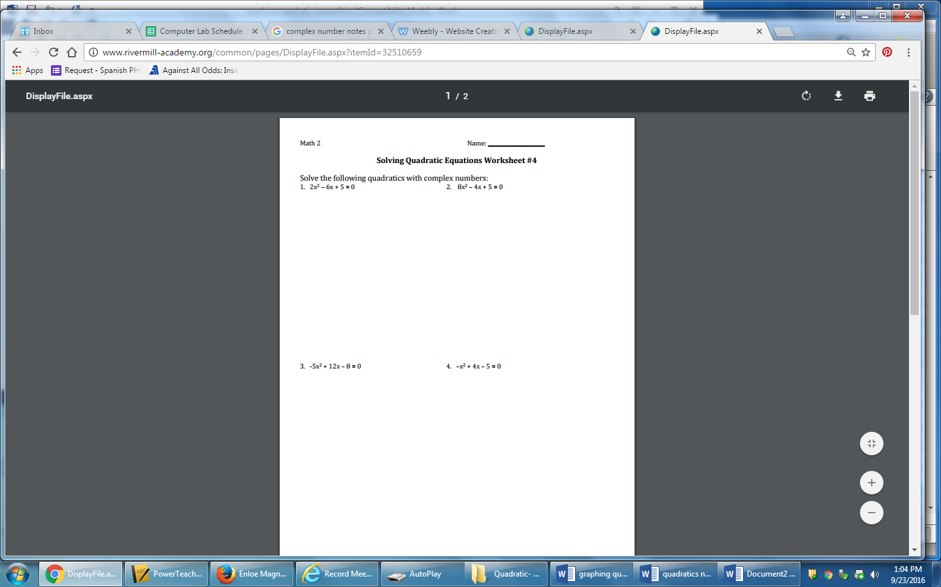

**Name:_______________________________ Period:____**

**Chapter 4 Notes Packet on Quadratic Functions and Factoring**

**Notes #15: Graphing quadratic equations in standard form, vertex form, and intercept form.**

***A. Intro to Graphs of Quadratic Equations: ***

* A ____________________ is a function that can be written in the form  where a, b, and c are real numbers and a0. Ex:   
* The graph of a quadratic function is a U-shaped curve called a ________________. The maximum or minimum point is called the _____________

**Identify the vertex of each graph; identify whether it is a minimum or a maximum.**

**1.) 2.)**

Vertex: ( , ) _________ Vertex: ( , ) _________

**3.) 4.)**

Vertex: ( , ) _________ Vertex: ( , ) _________

***B.* Key Features of a Parabola: 

|  |
| --- |
| * **Direction of Opening:** When , the parabola opens ________:   When , the parabola opens ________:   * **Width:** When , the parabola is _______________ than   When , the parabola is the ________ width as  When , the parabola is ________ than   * **Vertex:** The highest or lowest point of the parabola is called the vertex, which is on the axis of symmetry. To find the vertex, plug in and solve for *y*. This yields a point (____, ____) * **Axis of symmetry:** This is a vertical line passing through the vertex. Its equation is: * ***x*-intercepts:** are the 0, 1, or 2 points where the parabola crosses the *x*-axis. Plug in *y* = 0 and solve for *x*. * ***y*-intercept:** is the point where the parabola crosses the *y*-axis. Plug in *x* = 0 and solve for *y.* |

**Without graphing the quadratic functions, complete the requested information:**

|  |  |
| --- | --- |
| **5.)**  What is the direction of opening? _______  Is the vertex a max or min? _______  Wider or narrower than *y* = *x*2 ? __________ | **6.)**  What is the direction of opening? _______  Is the vertex a max or min? _______  Wider or narrower than *y* = *x*2 ? ___________ |
| **7.)**  What is the direction of opening? _______  Is the vertex a max or min? _______  Wider or narrower than *y* = *x*2 ? __________ | **8.)**  What is the direction of opening? _______  Is the vertex a max or min? _______  Wider or narrower than *y* = *x*2 ? ___________ |

|  |  |
| --- | --- |
| The parabola *y* = *x*2 is graphed to the right.  Note its vertex (___, ___) and its width.  You will be asked to compare other parabolas to this graph. |  |

***C.* Graphing in STANDARD FORM (**): we need to find the vertex first.**

|  |  |
| --- | --- |
| **Vertex**  - list *a = ____, b = ____, c = ____*  - find *x*  =  - plug this *x*-value into the function (table)  - this point (___, ___) is the vertex of the parabola | **Graphing**  - put the vertex you found in the center of  your *x*-*y* chart.  - choose 2 *x*-values less than and 2 *x*-values more than your vertex.  - plug in these *x* values to get 4 more points.  - graph all 5 points |

Find the vertex of each parabola. Graph the function and find the requested information

|  |  |
| --- | --- |
| **9.)** *f(x)=* -*x*2 + 2*x* + 3 *a* = ____, *b* = ____, *c* = ____ | Vertex: _______  Max or min? _______  Direction of opening? _______  Axis of symmetry: ________  Compare to the graph of *y* = *x*2  _________________________ |

|  |  |
| --- | --- |
| **10.)**  *h*(*x) =* 2*x*2 + 4*x* + 1 | Vertex: _______  Max or min? _______  Direction of opening? _______  Axis of symmetry: ________  Compare to the graph of *y* = *x*2  _________________________ |
| **11.)** *k(x) =* 2 – *x* –*x*2 | Vertex: _______  Max or min? _______  Direction of opening? _______  Axis of symmetry: ________  Compare to the graph of *y* = *x*2  _________________________ |

**12.)** State whether the function y = −3x2 + 12x − 6 has a minimum value or a maximum

value. Then find the minimum or maximum value.

**13.)** Find the vertex of  . State whether it is a minimum or maximum. Find that minimum or maximum value.

|  |
| --- |
| Another useful form of the quadratic function is the vertex form: ________________________________.  **GRAPH OF VERTEX FORM *y* = *a*(*x* − *h*)2+ *k***  The graph of *y* = *a*(*x* − *h*)2 *+ k* is the parabola *y* = *ax*2 translated ___________ *h* units and ___________ *k* units.   * The vertex is (___, ___). * The axis of symmetry is *x* = ___*.* * The graph opens up if a ___ 0 and down if a *___* 0. |

Find the vertex of each parabola and graph.

|  |  |
| --- | --- |
| **13.)** | Vertex: _______ |
| **14.)** | Vertex: _______ |

**15.)** Write a quadratic function in vertex form for the function whose graph has its vertex

at (-5, 4) and passes through the point (7, 1).