Common Core Math II Name Date

Rational Exponents & Radicals

C:\Users\Diana\AppData\Local\Microsoft\Windows\Temporary Internet Files\Content.IE5\JHSK0LRS\MC900048774[1].wmfRaising a number to the power of ½ is the same as performing a familiar operation. Let’s take a look at the graph of $y=x^{1/2}$ to discover that operation.

Part 1:

Step 1: Type $x^{1/2}$ into the y= screen on your graphing calculator.

Step 2: Look at the table of values generated by this function. Verify that you have the same values as the rest of your class. (It is very easy to make a mistake when you type in the exponents here!)

Step 3: Discuss with your classmates what you believe to be the relationship between the x and y values in the table. Where have you seen this relationship before? Summarize your findings in a sentence.

Part 2:

Step 1: Type $x^{1/3}$ into the y= screen on your graphing calculator.

Step 2: Look at the table of values generated by this function. Verify that you have the same values as the rest of your class. (It is very easy to make a mistake when you type in the exponents here!)

Step 3: Discuss with your classmates what you believe to be the relationship between the x and y values in the table. Have you seen this relationship before? Summarize your findings in a sentence.

Part 3:

Step 1: Type ${25}^{x}$ into the y= screen on your graphing calculator.

Step 2: Adjust your table so that the values go up by ½ and begin at 0. (to do this hit 2nd, window) Verify that your table contains the same values as the rest of your class.

Step 3: Discuss with your classmates the pattern you see. Use the table below to help you see the pattern. (One row has been completed for you). Summarize your findings in the space beside the table.

|  |  |  |  |  |
| --- | --- | --- | --- | --- |
| X (exponent) | X (exponent) as a fraction with a denominator of 2 | Y1 (25x) | Rewrite Y1 as a power of 25 with fraction exponents | Rewrite Y1 as a power of |
| 0 |  |  |  |  |
| .5 |  |  |  |  |
| 1 |  |  |  |  |
| 1.5 |  | 125 |  | 3 |
| 2 |  |  |  |  |
| 2.5 |  |  |  |  |
| 3 |  |  |  |  |
| 3.5 |  |  |  |  |

How could you use this pattern to find the value of ${36}^{3/2}$? Check your answer in the calculator.

**Part 4:**

Generally speaking, how can you find the value of an expression containing a rational exponent. Use the expression $a^{m/n}$ to help you in your explanation.

You try: Rewrite each of the following expressions in radical form.

|  |  |  |  |
| --- | --- | --- | --- |
|  |  |  | *y*-9/8 |
|  |  |  | *x 1.2* |

Now, reverse the rule you developed to change radical expressions into rational expressions.

|  |  |  |
| --- | --- | --- |
|  |  |  |
|  |  |  |
|  |  |  |

**Part 5:**

Earlier in this unit, you learned that when written in radical form, it’s only possible to write two multiplied radicals as one if the index is the same. However, if you convert the radical expressions into expressions with rational exponents, you CAN multiply or divide! Give it a try ☺ Write your final answer as a simplified radical.

|  |  |  |
| --- | --- | --- |
| $$\frac{12\sqrt[3]{y}}{4\sqrt{y}}$$ Extra Practice! | $${\left(\frac{\sqrt[3]{a^{2}}}{\sqrt{b}}\right)}^{-6}$$ | $${\left(2\sqrt[4]{a}\right)}^{3}∙\sqrt{a^{3}}$$ |
| $$\sqrt[4]{x^{12}}∙\sqrt{y^{-2}}$$ | $$\frac{\sqrt{64x^{3}}}{\sqrt[3]{512x^{9}}}$$ | $$\sqrt[4]{625x^{8}}$$ |
| $$\sqrt[7]{x^{2}}∙\sqrt[14]{x^{3}}$$ | $$\frac{1}{\sqrt[3]{-27x^{9}}}$$ | $${\left(\sqrt{x}∙\sqrt[3]{y^{2}}\right)}^{-6}$$ |

Common Core Math II Name Date

Solving Equations with Rational Exponents

**Notes:**

You know a lot about inverses in mathematics – we use them every time we solve equations.

An “inverse” is…

How do we apply inverses to radicals and rational exponents? Remember our rule:

$$\sqrt[n]{x}=x^{\frac{1}{n}}$$

We will use this to solve for the given variables.

**Example 1: Example 2: Example 3:**

$\sqrt[6]{x}=18$ $\sqrt[5]{x^{4}}=20$ ${\left(\sqrt[3]{x}\right)}^{5}=20$

**Practice:**

|  |  |  |
| --- | --- | --- |
| **Skill** | Partner A | Partner B |
| **1** | $$\sqrt[4]{a}=14$$ | $$\sqrt[5]{b}=50$$ |
| **2** | $$\sqrt[5]{a^{9}}=26$$ | $$\sqrt[4]{b^{3}}=27$$ |
| **3** | $${\left(\sqrt[7]{a}\right)}^{3}=21$$ | $${\left(\sqrt{b}\right)}^{5}=12$$ |
| **4** | $$a^{\frac{1}{5}}=50$$ | $$b^{\frac{1}{4}}=14$$ |
| **5** | $$a^{\frac{3}{4}}=27$$ | $$b^{\frac{9}{5}}=26$$ |
| **6** | $${\left(a^{\frac{1}{2}}\right)}^{5}=12$$ | $${\left(b^{\frac{1}{7}}\right)}^{3}=21$$ |

Work with a partner – Decide who will be Partner A and who will be Partner B.

Compare the answers you got when you practiced Skills 1-3 with the answers you got when you practiced Skills 4-6. Work with your partner to explain your findings.

The previous problems only had one step. You cannot do this step until the radical or rational exponent is isolated on one side of the equation. You can isolate the radical using the inverses discussed at the beginning of the lesson. There are also some problems below in which the rational exponent or radical is applied to the entire side of the equation. Only in these situations will you undo the rational exponents or radicals first. Before solving the entire problem, make sure you know what the first step will be.

|  |  |
| --- | --- |
| $$x^{1/4}-2=3$$ Step 1 | $$4x^{7}-6=-2$$ Step 1 |
| $$3\left(x^{2/3}+5\right)=207$$ Step 1 | $$1450=800{\left(1+\frac{x}{12}\right)}^{7.8}$$ Step 1 |
| $$14.2=222.1∙x^{3.5}$$ Step 1 | $$3x^{3/4}+5=53$$ Step 1 |
| $$x^{1/2}-5=0$$ Step 1 | $${\left(2x+7\right)}^{1/2}=3$$ Step 1 |
| $$\sqrt[3]{x-2}=4$$ Step 1 | $$\sqrt{a+2}-2=12$$ Step 1 |
| $$\sqrt{2x-5}=9$$ Step 1 | $$\sqrt[4]{3x+1}-5=0$$ Step 1 |

The next few problems are…different. We’re going to come across some equations that have no solution and some that have two solutions. Remember, you can always check your answers by substituting your solution into the equation to make sure it works. In fact, you really ***need*** to check your answers to these problems! When we solve an equation correctly, but the answer doesn’t work when we check it, we call the solution extraneous.

$$\sqrt{a+2}-2=a$$

$$\sqrt{3x-2}=-5$$

$${\left(2x+7\right)}^{1/2}-x=2$$

$$3x^{4/3}+5=53$$

Practice Rational Exponent Quiz

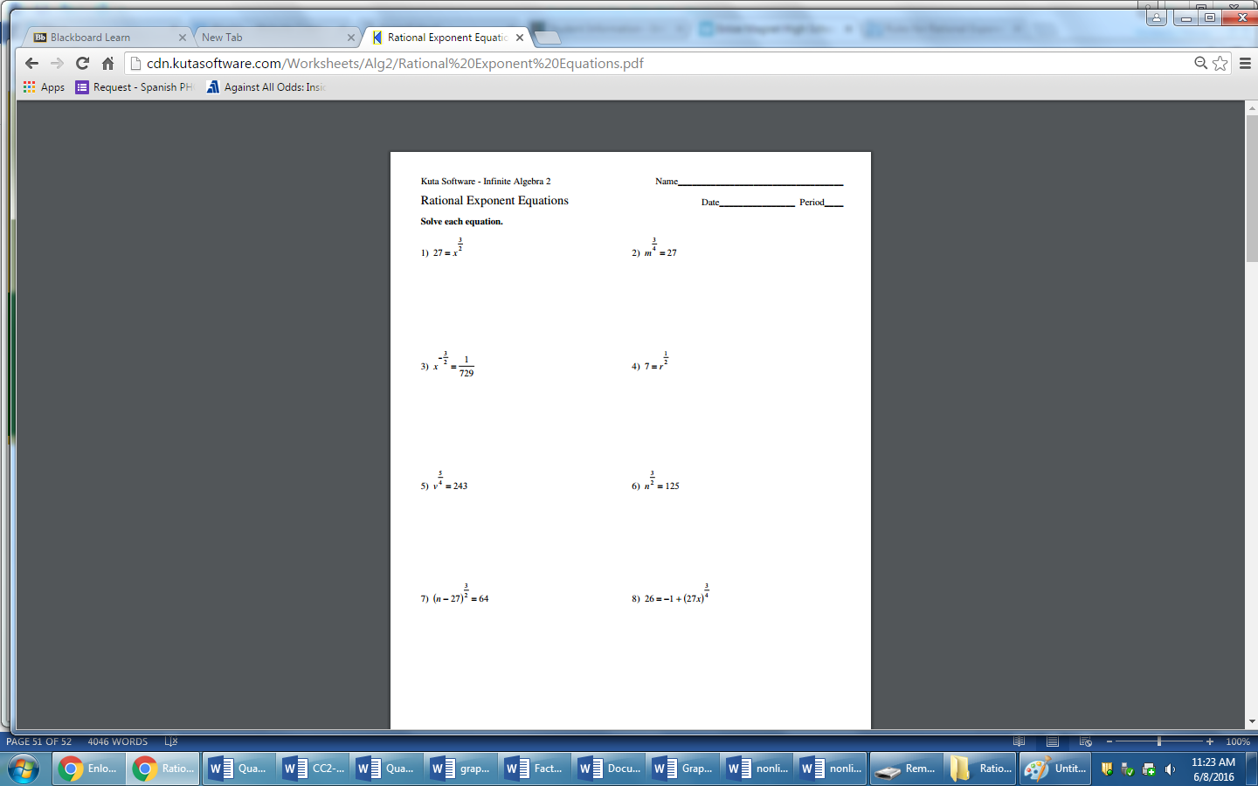

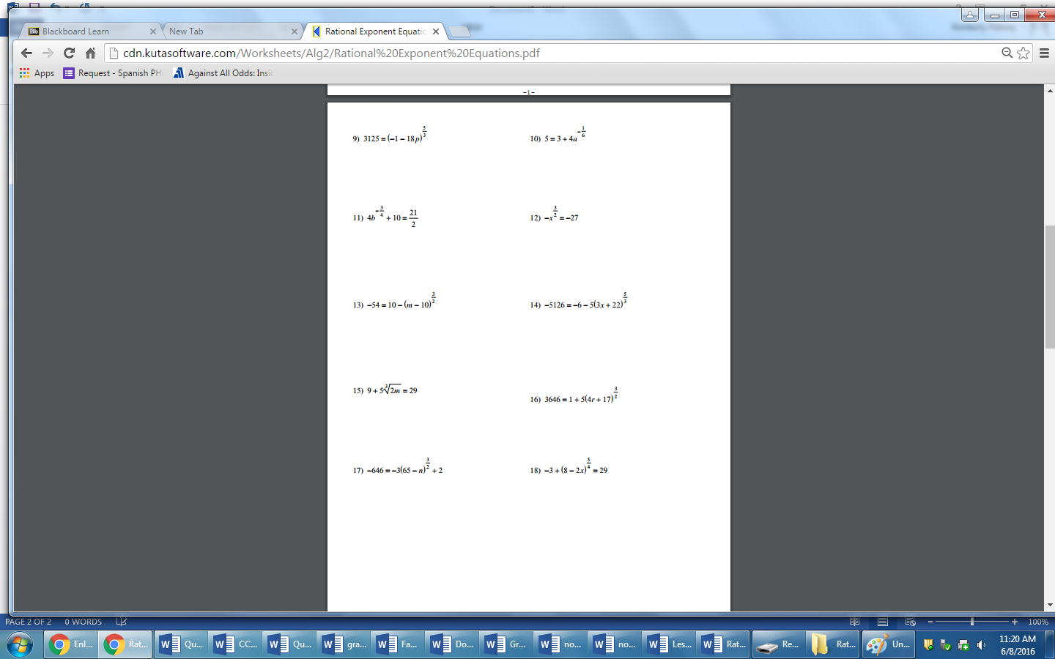

ex