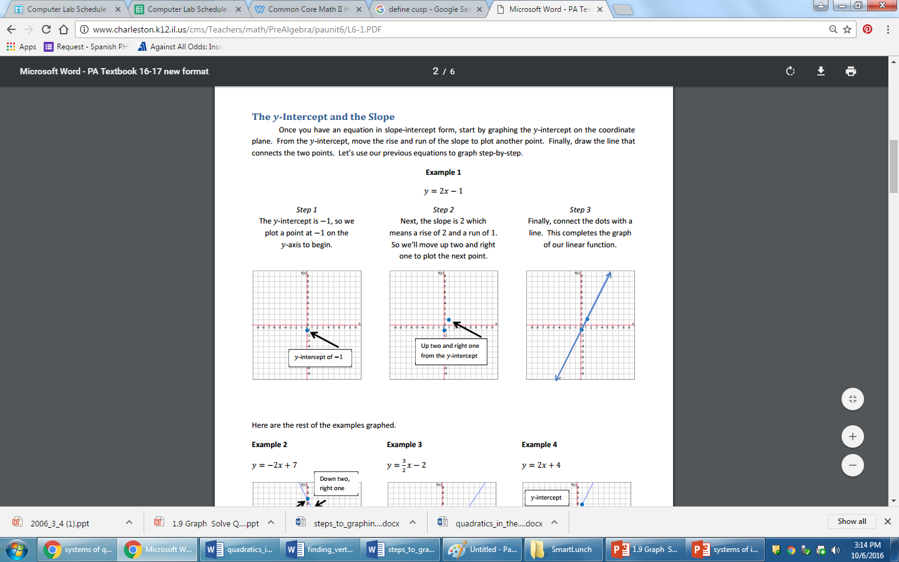



**Graphing systems of linear equations**

1. We show the solution to a system of linear inequalities by graphing them.

This process is easier if we put the inequalities into Slope-Intercept Form, *y* = *mx* + *b*.

2. Graph the line using the *y*-intercept & slope.

a) If the inequality is < or >, make the lines dotted.

b) If the inequality is < or >, make the lines solid.

3. The solution also includes points not on the line, so you need to shade the region of the graph:

a) above the line for ‘y >’ or ‘y ≥’.

b) below the line for ‘y <’ or ‘y ≤’.

Example:

*a*: 3*x* + 4*y* > - 4

*b*: *x* + 2*y* < 2

Put in Slope-Intercept Form:

 

Graph each line, make dotted or solid and shade the correct area.

 



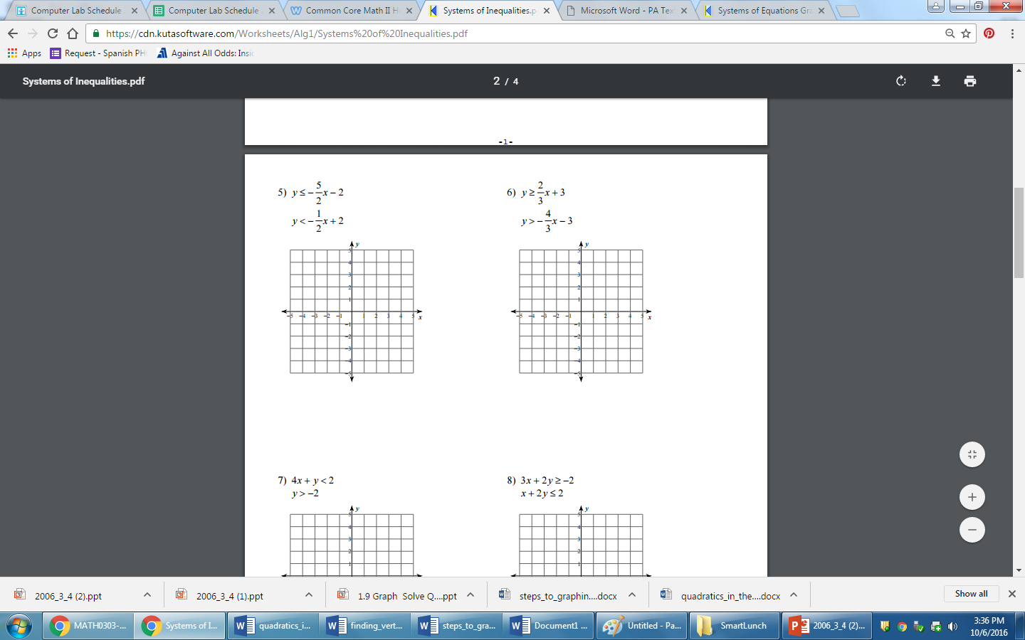



Steps to graphing quadratic inequalities:

1. Determine if you will use a solid or a dashed line to graph.
2. Find the vertex using: $x=-\frac{b}{2a}$, then plug this value in solve to for y.
3. Find the x-intercepts using:
   1. Factoring, or
   2. Quadratic formula
   3. Completing the square
4. Plot vertex and x-intercepts; ***If there are no x-intercepts, you will need to pick 2 points around the vertex (one on the left and one on the right).
5. Shade appropriate region on graph
6. Check graph on calculator

Try it out!!!!

1. *y* ≤ *x*2 + 3*x* + 2 2. *y* > *x*2 + 4*x* + 4

3. *y* ≥ *x*2 – 7*x* + 10 4. *y* < *x*2 – 9

5. *y* ≤  6. *y* > 

7. y ≥  8. y < 