Determine whether each situation is an example of a direct variation or inverse variation. Write and equations of variation to represent the situation and solve for the indicated information.

1) The volume V of a gas kept at a constant - temperature varies inversely with the pressure p. If the pressure is 24 pounds per square inch, the volume is 15 cubic feet. What will the volume be when the pressure is 30 pounds per square inch?

2) The amount of money spent at the gas station varies directly with the number of gallons purchased. When 11.5 gallons of gas were purchased the cost was $37.72. How much would 8 gallons of gas cost?

3) The time to complete a project varies inversely with the number of employees. If 3 people can complete the project in 7 days, how long will it take 5 people?

4) The time needed to travel a certain distance varies inversely with the rate of speed. If it takes 8 hours to travel a certain distance at 36 miles per hour, how long will it take to travel the same distance at 60 miles per?

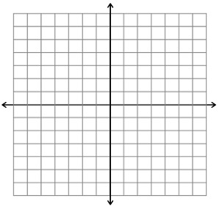
Graph each of the functions below.

5)$f\left(x\right)=\sqrt{x-4}+2$ 6) $f\left(x\right)=\frac{1}{x}-3$

7) $f\left(x\right)= \frac{1}{x+2}+1$ 8) $f\left(x\right)=2\sqrt{x-3}$

Write the equation for each graph.

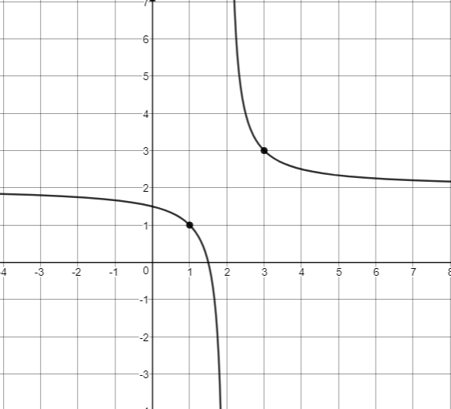
9. _________________________________ 10. ________________________________
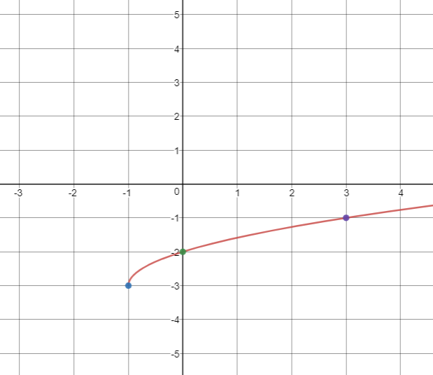

11. __________________________________ 12. ________________________________
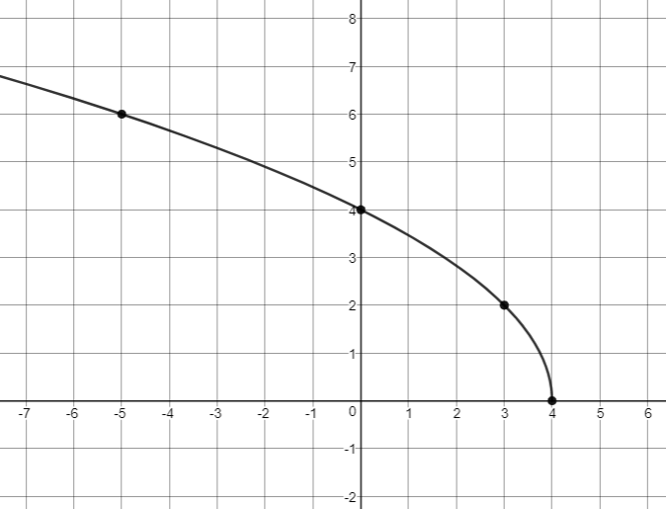
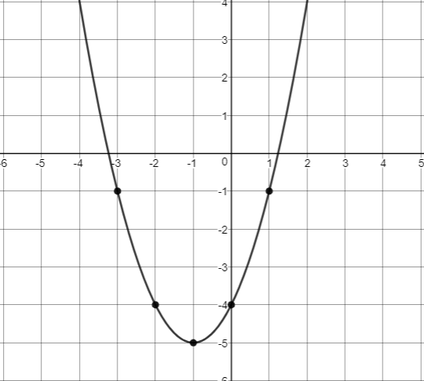

Describe the transformations of the following graphs compared to the parent functions.

Use algebraic reasoning, graphs, or tables to solve each equation. Show your work.

$$x+2=\sqrt{4-x}$$

$\frac{3}{x}$ $=2x+1$

