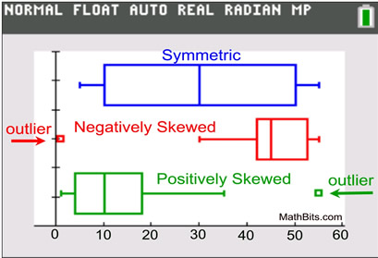

Steps to make a box and whisker plot with the TI 83 calculator.
1. Turn on the Stat Plot. Press [2nd] [Stat Plot]. Press 'Enter'. Press 'Enter' again to turn Plot 1 on.
2. Select a Box Plot icon. The first one will show outliers. The second icon will not show the outliers.
3. Enter Data in L1 of [Stat]
4. View Box Plot by going to [ZOOM] 'Stat' (#9). Or use the arrow keys to scroll down to number 9. Press 'Enter'.
5. Press [Trace] and the arrow keys to view the values of the Min, Q1, Median, Q3, and Max.
6. Go to the [2nd] [Stat]. In Plot1, use the arrow keys to the 2nd Box Plot. Press 'Enter'. This plot will not show the outliers.

Answering questions based on the box and whisker plot
⎕ When asked about the center of the data – look to the median, which is found in the middle of the box and whisker plot
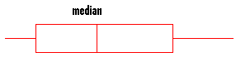 The median is 34
20 25 30 35 40 45 50 55
⎕ When asked about the spread of the data – think about range, which is the smallest number subtracted from the maximum number
The spread of this data is 55 – 20 = 35
20 25 30 35 40 45 50 55

⎕ Determine the shape of the box and whisker plot
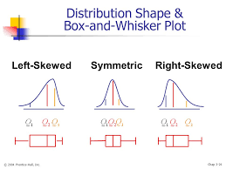
⎕ When you are asked about the data, write a true statement about the data. For Example, the lowest temperature is 20˚ or the median is 35 ˚
20 25 30 35 40 45 50 55

