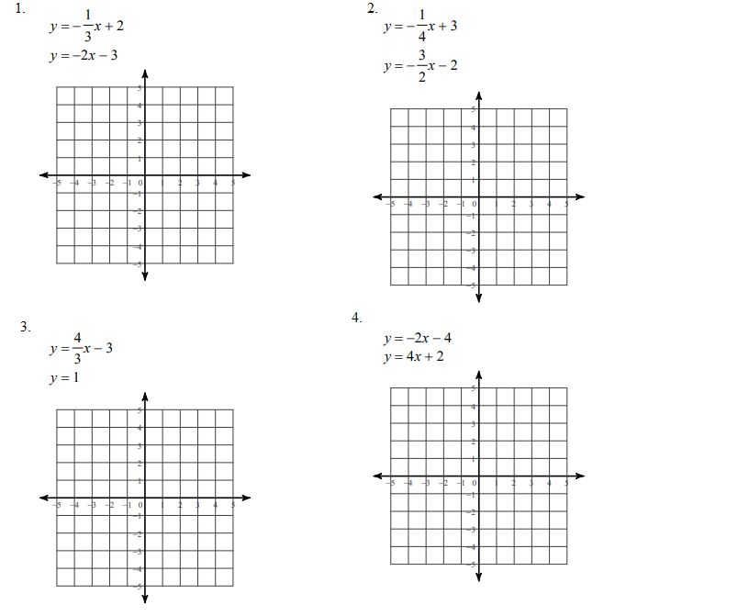
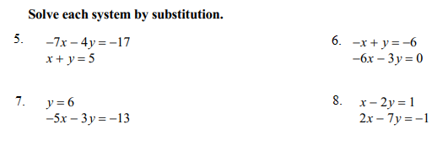

9. Two medium eggs and one cup of ice cream contain 599 milligrams of cholesterol. One medium egg and two cups of ice cream contain 376 milligrams of cholesterol (25 milligrams more than the suggested daily intake of cholesterol). Determine the cholesterol content in each item.

10. Your family receives basic cable television and one movie channel for $39 a month. Your neighbor receives basic cable and two movie channels for $45.50. What is the monthly charge for basic cable? (Assume that each movie channel has the same monthly charge.)

11. At a restaurant the cost for a breakfast taco and a small glass of milk is $2.10. The cost for 2 tacos and 3 small glasses of milk is $5.15. Which pair of equations can be used to determine t, the cost of a taco, and m, the cost of a small glass of milk?

12. Two pan pizzas and two beef burritos provide 3100 calories. One pan pizza and one beef burrito provide 1550 calories. How many calories are in each item?

