Day 6: Quiz Review
Graph the image of the figure using the transformation given AND write the algebraic rule.
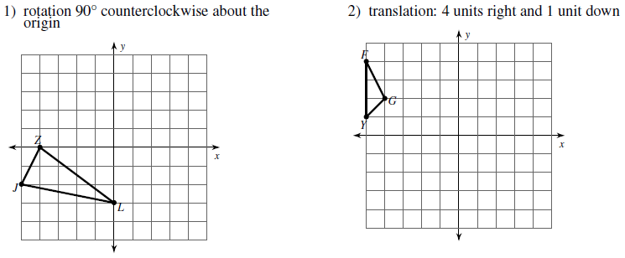
Algebraic Rule:
Algebraic Rule:
Algebraic Rule:
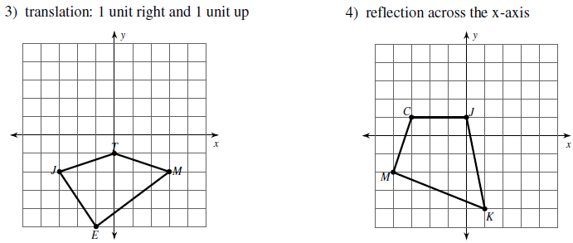
Algebraic Rule:
Write a verbal description and a motion rule, as requested, to describe each transformation.
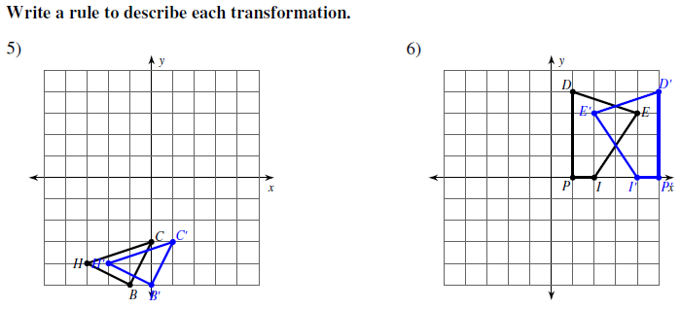
Description:

Description:

Algebraic Rule:
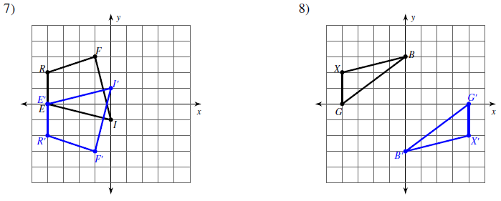
Description:

Algebraic Rule:
Description:

Algebraic Rule:
Graph the image of the figure using the transformation given and write the algebraic rule.
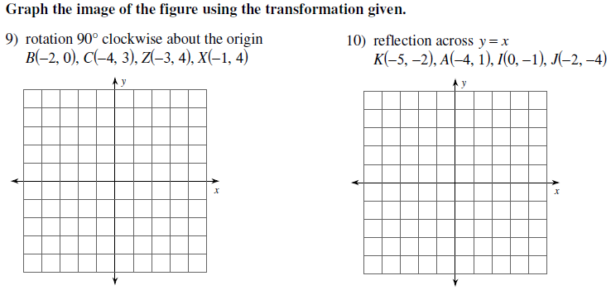
Algebraic Rule:
Algebraic Rule:
Find the coordinates of the vertices of the figure using the transformation given and write the algebraic rule, as requested.
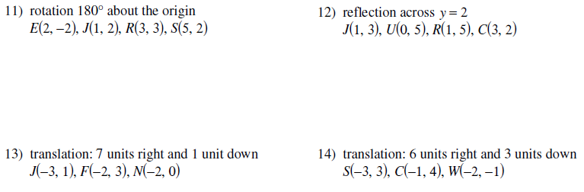
Vertices:
Algebraic Rule:
Vertices:
Algebraic Rule:
Vertices:
Algebraic Rule:
Vertices:

