For each pair of points, draw in the line of reflection and find the equation of the line of reflection.
1. 2.
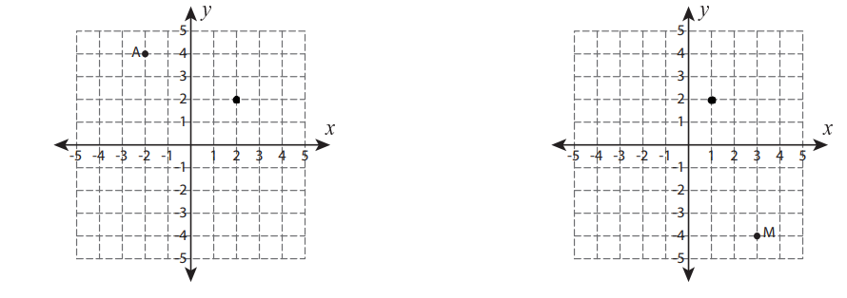
3. 4.

5. 6.
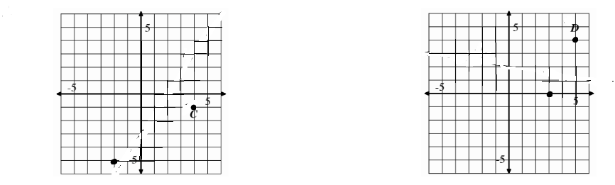
For each linear equation write the slope of a line parallel to the given line.
7. y = -1/2x + 4 8. 3x + 5Y = 15

For each linear equation write the slope of a line perpendicular to the given line.
9. y = 2/3x – 5 10. 2x -4y = 8

Find the slope and the distance between each pair of points.
11. Slope___________Distance__________ 12.Slope_________Distance_________

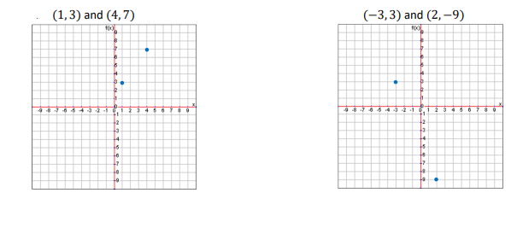
13. Slope___________Distance__________ 14.Slope_________Distance_________
