Using SOH-CAH-TOA, answer the following.
- What does the SOH represent?

- What does the CAH represent?

- What does the TOA represent?

Use the picture below for problems 4-6.
B
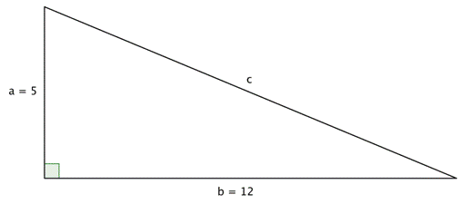

C
A

- Find the length of the missing side of the triangle above.

- Set up the appropriate trigonometric ratios. ( Don’t forget to label the pieces)
- $\sin\left(A\right)=$ d) $\sin{B=}$

- $\cos\left(A\right)=$ e)$\cos{B}=$

- $\tan\left(A\right)=$ f) $\tan{B}=$

- Solve for the unknown angles.

- $<A=$ b) $<B=$
Solve for the missing angle round the nearest tenth.

Solve for a and x.
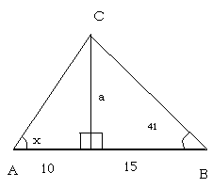
13)

Solve for the missing variable round to the nearest tenth:

- $\sin\left(50°\right)=x$

- $\tan\left(45°\right)=x$

- $\cos{(120°)}=x$

- $\tan\left(x\right)=1.5$
- $\sin\left(x\right)=\frac{2}{5}$

- $3\cos\left(x\right)= 2$

- $12\sin\left(x\right)+8=18$

- $5\tan\left(x\right)-6=4$

Solve the following problems ( Hint draw a picture)

Picture:
- A ladder with its foot on a horizontal flat surface rests against a wall. It makes an angle of 30° with the horizontal. The foot of the ladder is 41 ft from the base of the wall. Find the height of the point where the ladder touches the wall.

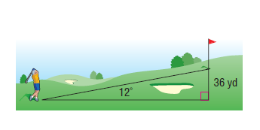
- A golfer is standing at the tee, looking up to the green on a hill. If the tee is 36 yards lower than the green and the angle of elevation from the tee to the hole is 12°, find the distance from the tee to the hole.

- A tree stand 30 yards tall is attached to a zip cord. The angle of depression between the zip line and a platform on the ground is $15°$ , find the distance you would travel on this zip line

Picture:

- From the top of a tower of height 50 ft, the angles of depression of two cars on a straight road at the same level as that of the base of the spire and on the same side of it are 25° and 40°. Calculate the distance between the two cars.
Picture:

