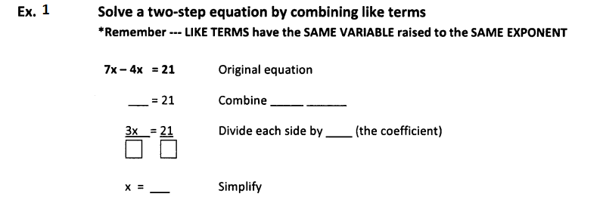
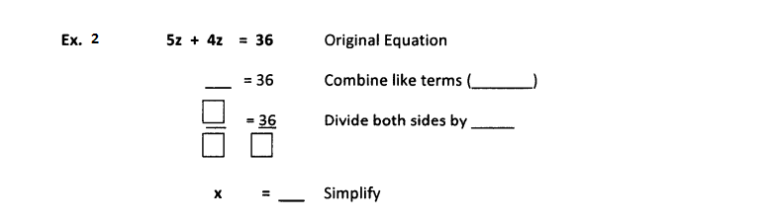
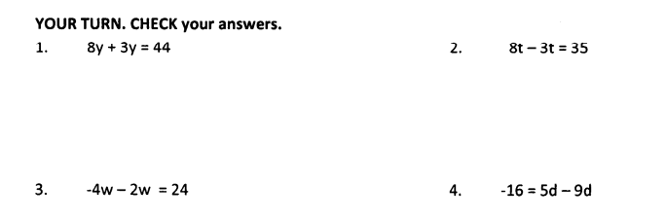

5. 6x + 3x = 18 $⎕$ Look on each side of the equal sign and combine like terms
___ = ____ $⎕$ Simplify ( bring down the remaining terms)
$⎕$ Divide both sides by______

6. 7x – 4x = 27 $⎕$ Look on each side of the equal sign and combine like terms
___ = ____ $⎕$ Simplify ( bring down the remaining terms)
$⎕$ Divide both sides by______

7. -5x + 13x = 64 $⎕$ Look on each side of the equal sign and combine like
terms
___ = ____ $⎕$ Simplify ( bring down the remaining terms)
$⎕$ Divide both sides by______

8. -10x -5x = 45 $⎕$ Look on each side of the equal sign and combine like
terms
___ = ____ $⎕$ Simplify ( bring down the remaining terms)
$⎕$ Divide both sides by______

9. 2x + 8 + 2x = 32 $⎕$ Look on each side of the equal sign and combine like
Terms
$⎕$ If the constant is positive, subtract____from both sides
If the constant is negative, add ____ to both sides

___ = ____ $⎕$ Simplify ( bring down the remaining terms)
$⎕$ Divide both sides by______

10. 6x -5x + 7x = 34 $⎕$ Look on each side of the equal sign and combine like
Terms

___ = ____ $⎕$ Simplify ( bring down the remaining terms)
$⎕$ Divide both sides by______

11. -15 + 3x – 7x = -43 $⎕$ Look on each side of the equal sign and combine like
Terms
$⎕$ If the constant is positive, subtract____from both sides
If the constant is negative, add ____ to both sides
___ = ____ $⎕$ Simplify ( bring down the remaining terms)
$⎕$ Divide both sides by______

12. 12 -10x + 5x = -18 $⎕$ Look on each side of the equal sign and combine like
Terms
$⎕$ If the constant is positive, subtract____from both sides
If the constant is negative, add ____ to both sides

___ = ____ $⎕$ Simplify ( bring down the remaining terms)
$⎕$ Divide both sides by______
13. 6a – 2a = -48 $⎕$ Look on each side of the equal sign and combine like
Terms
___ = ____ $⎕$ Simplify ( bring down the remaining terms)
$⎕$ Divide both sides by______

14. 2r + 8 - r = -7 $⎕$ Look on each side of the equal sign and combine like
Terms
$⎕$ If the constant is positive, subtract____from both sides
If the constant is negative, add ____ to both sides

___ = ____ $⎕$ Simplify ( bring down the remaining terms)
$⎕$ Divide both sides by______

15. -9a -3a = -36 $⎕$ Look on each side of the equal sign and combine like
Terms

___ = ____ $⎕$ Simplify ( bring down the remaining terms)
$⎕$ Divide both sides by______

16. 5x + 4x - 27 = 81 $⎕$ Look on each side of the equal sign and combine like
Terms
$⎕$ If the constant is positive, subtract____from both sides
If the constant is negative, add ____ to both sides

___ = ____ $⎕$ Simplify ( bring down the remaining terms)
$⎕$ Divide both sides by______

17. 2n + 3n + 7 = -43 $⎕$ Look on each side of the equal sign and combine like
Terms
$⎕$ If the constant is positive, subtract____from both sides
If the constant is negative, add ____ to both sides

___ = ____ $⎕$ Simplify ( bring down the remaining terms)
$⎕$ Divide both sides by______

18. 3h – 5h+ 11 = 17 $⎕$ Look on each side of the equal sign and combine like
Terms
$⎕$ If the constant is positive, subtract____from both sides
If the constant is negative, add ____ to both sides

___ = ____ $⎕$ Simplify ( bring down the remaining terms)
$⎕$ Divide both sides by______

