Unit 2 Practice Test #2
NAME ______________________________________________ Period_____________

1. Which of the following correctly describes the graph of $y=3x-2$
A. The graph of this equation has a positive slope and a positive y-intercept.
B. The graph of this equation has a negative slope and a negative y-intercept.
C. The graph of this equation has a negative slope and a positive y-intercept.
D. The graph of this equation has a positive slope and a negative y-intercept.

2. For a few months, Derrick recorded the amount of fluid ounces of laundry detergent remaining (y) after his family washed (x) loads of laundry. The equation is $y=-2x+50$. Which statement correctly describes this situation?
A. The amount of ounces left in the laundry detergent bottle decreases linearly.
B. The amount of ounces left in the laundry detergent bottle increases linearly.
C. The amount of ounces left in the laundry detergent bottle decreases exponentially.
D. The amount of ounces left in the laundry detergent bottle increases exponentially.

3. Write the equation of the line that passes through the points (-5, -4) and (3, 12) in point slope form.

4. Write the equation of the line that passes through the points (-5, -4) and (3, 12) in slope intercept form.

5. Find the equation of the line that has an undefined slope and passes through the point
(-2, 5).

6. Thomas has been working to save money and wants to have an equation to model the amount of money in his bank account. He has been depositing $200 a month consistently, he doesn’t remember how much money he deposited initially, however on his last statement he saw that his account has been open for 8 months and currently has $2000 in it. Create an equation for Thomas.

7. Graph y = $-2x$ + 4 8. Graph y = $\frac{1}{2}$x - 2
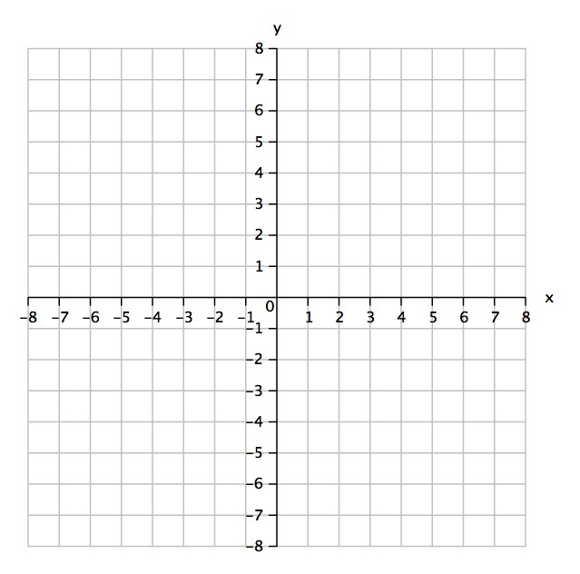
9. Graph the following equation. 10. Graph the following equation.
y + 1 = - 3( x + 2) y – 5 = ¼ ( x – 3)
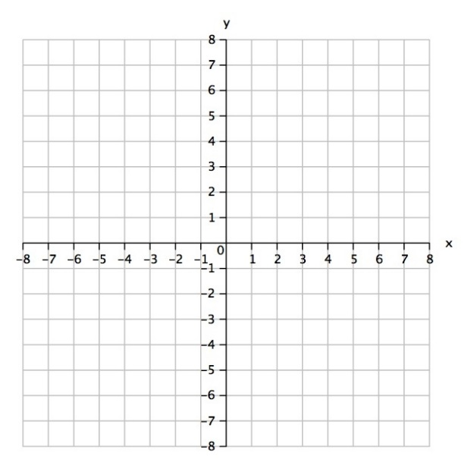

11. Write the equation of the line graphed below. y = ___________________________
Simplify.
12. ${3x}^{-3}∙{4x}^{-2}$ 13. (-2x⁻⁴y⁻³)³ 14. $\frac{4xy^{3}z}{{2x}^{3}yz}$ 15. -1200⁰

16. Which equation matches the table?
X | 0 | 1 | 2 | 3 | 4 | 5
y | 4 | 8 | 16 | 32 | 64 | 128

A. $y=x+4$ B. $y=4{(2)}^{x}$ C. $y=2x+1$ D. $y=2{(4)}^{x}$

Decide whether the word problem represents a linear or exponential function. Circle either linear or exponential. Then, write the function formula.
17. “A library has 18000 books, and is losing 200 books each year.” Linear or exponential?
y = __________________.
18. “A bank account starts with $20000. Every month, the amount of money in the account is halved.” Linear or exponential? y = __________________.

