Unit 2 Practice Test
NAME ______________________________________________ Period_____________

1. Which of the following correctly describes the graph of $y=\frac{1}{4}x-2$
A. The graph of this equation has a positive slope and a positive y-intercept.
B. The graph of this equation has a negative slope and a negative y-intercept.
C. The graph of this equation has a negative slope and a positive y-intercept.
D. The graph of this equation has a positive slope and a negative y-intercept.

2. For a few months, Derrick recorded the amount of fluid ounces of laundry detergent remaining (y) after his family washed (x) loads of laundry. The equation is $y=2.6x+50$. Which statement correctly describes this situation?
A. The amount of ounces left in the laundry detergent bottle decreases linearly.
B. The amount of ounces left in the laundry detergent bottle increases linearly.
C. The amount of ounces left in the laundry detergent bottle decreases exponentially.
D. The amount of ounces left in the laundry detergent bottle increases exponentially.

3. Write the equation of the line that passes through the points (-5, -3) and (2, 11) in point slope form.

4. Write the equation of the line that passes through the points (-5, -3) and (2, 11) in slope intercept form.

5. Find the equation of the line that has a slope of zero and passes through the point (-2, 5).

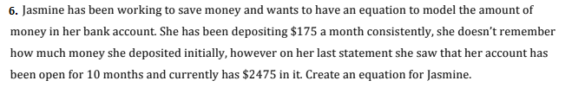
7. Graph y = $-\frac{1}{4}$x + 2 8. Graph y = $3$x + 2
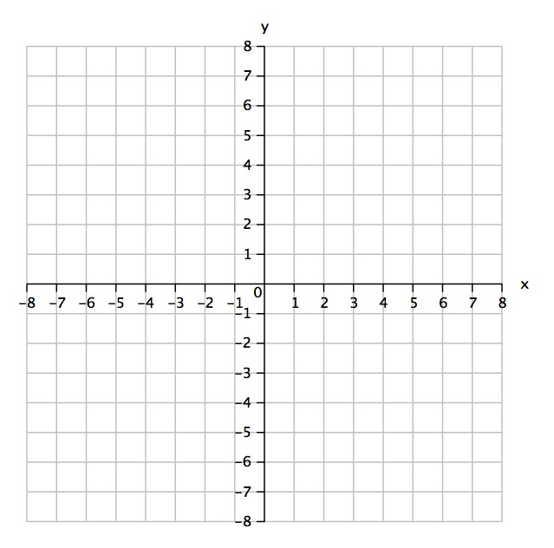
9. Graph the following equation. 10. Graph the following equation.
y + 4 = - 3( x + 2) y – 4 = ½ ( x – 1)
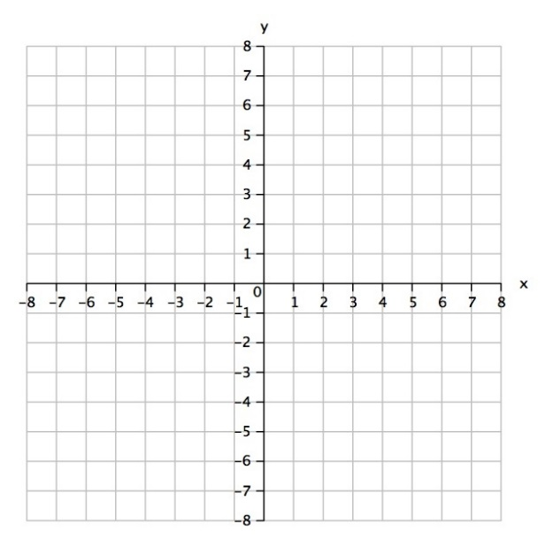

11. Write the equation of the line graphed below.
y=____________________
Simplify.
12. ${2x}^{3}∙{5x}^{-2}$ 13. (2x²y⁻³)³ 14. $\frac{xy^{3}z}{x^{3}}$ 15. X⁰

16. Which equation matches the table?
X | 0 | 1 | 2 | 3 | 4 | 5
y | 3 | 6 | 12 | 24 | 48 | 96

A. $y=2{(3)}^{x}$ B. $y=x+3$ C. $y=3x+3$ D. $y=3{(2)}^{x}$

Decide whether the word problem represents a linear or exponential function. Circle either linear or exponential. Then, write the function formula.
17. “A library has 8000 books, and is adding 500 more books each year.” Linear or exponential? y = __________________.

18. “A bank account starts with $10. Every month, the amount of money in the account is tripled.” Linear or exponential? y = __________________.

